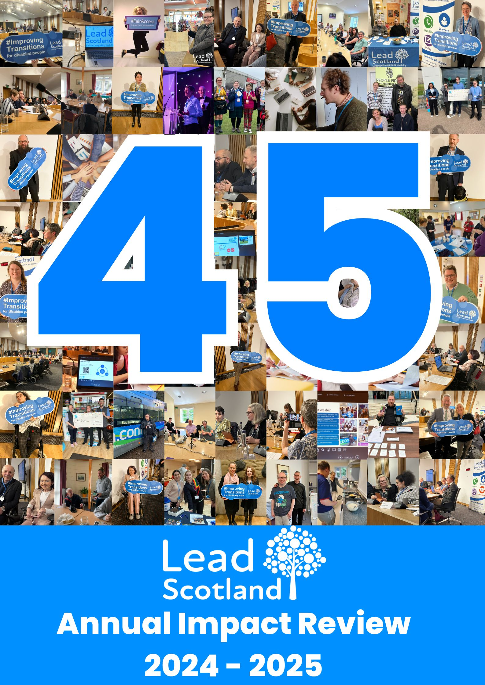

Contents

CEO/Chair Foreword, Emma Whitelock, Paul Smith 3

Summary of the Year 5

Our Strategic Performance 6

Aberdeenshire, Amy O’Reilly & Danni Phoenix-Kane 7

Digital Skills for Health and Wellbeing 7

Aberdeenshire Employability 8

Aberdeenshire Multiply 10

Dundee, Amy O’Reilly 12

Dundee Multiply 13

East Lothian, Danni Phoenix-Kane 14

East Lothian Multiply 14

Fife, Amy O’Reilly & Marie Lindsay 16

Fife Multiply 16

Fife Carers Digital Skills 17

Fife Adult Learning 18

Fife Adult Befriending Project 21

Fife Young Carer Befriending Project 23

Highland, Danni Phoenix-Kane 28

Highland Multiply 28

Moray, Danni Phoenix-Kane 31

Moray Multiply 31

Perth and Kinross, Amy O’Reilly 35

Perth and Kinross Tenants Project 36

North Lanarkshire, Amy O’Reilly 38

Scotland wide cyber project, Michael Chamberlain-Cove 39

Helpline and Information Services, Rebecca Curran-Scarlett 43

Policy Work, Rebecca Curran-Scarlett 45

Looking ahead to 2025-26 47

Our supporters 48

## CEO/Chair Foreword, Emma Whitelock, Paul Smith

We are pleased to present Lead Scotland’s Annual Impact Review for the year ending 31st March 2025. We are proud to celebrate our 45th anniversary, supporting 1,588 adult learners directly in 2024-25, with a 25% increase in local learners (730 up from 585 last year). It has been a bumper year for qualifications,154 up from 69 last year! We were thrilled to win the Digital Difference category at the Scottish Charity Awards and give the spotlight talk at the Cyber UK conference in Birmingham!

Lead Scotland was set up in 1979 to provide a home tuition service for disabled adults linking people with post school learning opportunities. In 2024-25, 46% of 718 local learners had at least one home visit in this period, compared with 54% pre-covid pandemic, this is still the only way some disabled people and carers can or will engage to get started in post school learning.

There are new challenges to navigate in an increasingly competitive funding landscape. Twice this year, we found our request for funding in a process where the public voted to choose between services they want to fund or save. Budget cuts and short-term funding threaten the hard-fought right for fair access to post-school learning services. The numbers of disabled people and unpaid carers in Scotland are increasing and levels of poverty, inequality and health outcomes are getting worse.

Evidence shows that an adult learning approach can lead to transformative change. However, a weak Community Learning and Development statutory instrument does not protect community-based adult learning sufficiently well from deepening local authority cuts. We hope the Scottish Government’s response to the Independent Review of CLD recommendations will improve this position otherwise there will be even less provision for disabled people and carers across Scotland.

In 2024-25 the UK Shared Prosperity Funding enabled us to set up six new numeracy projects, as half of working adults have low levels of numeracy, and disabled people experience compounded barriers to learn. Our Multiply projects across Scotland supported 306 learners, many of whom gained a qualification but this new funding which augmented local authority adult learning budgets ceased on the 31st March 2025 shrinking the availability of numeracy provision.

Since 2011 we have run Scotland’s only National Disabled Students’ Helpline providing advice and guidance about rights and entitlements for people to use to self-advocate. One third of all callers who contact us are in dispute with their institution, and they are increasingly looking for more than the tools to self-advocate; they are asking us to represent them. We are striving to close the gap around advocacy to improve access to early dispute resolution by seeking funding to extend our helpline to include advocacy if this is the only way to fill that gap.

We have performed well against our own strategic objectives, and we are incredibly grateful to all our funders and supporters. We will continue to find new opportunities to work with disabled people and carers and secure funding to deliver high quality learning, befriending, helpline and policy services.

Whilst we will endeavour to aim for the targets we set in our Strategic plan for 2025/26, we will be doing this against a backdrop of Government funding cuts and a hugely competitive environment to seek funds from other sources such as Trusts.

As we look ahead 2025-26, it is even more important that we seek to diversify our sources of income. We will work with disabled people, carers and allies seeking solutions which widen access to lifelong learning opportunities, and which lead to positive outcomes for individuals, families and communities across Scotland.

Paul Smith (Chair), Emma Whitelock (Chief Executive Officer)

## Summary of the Year

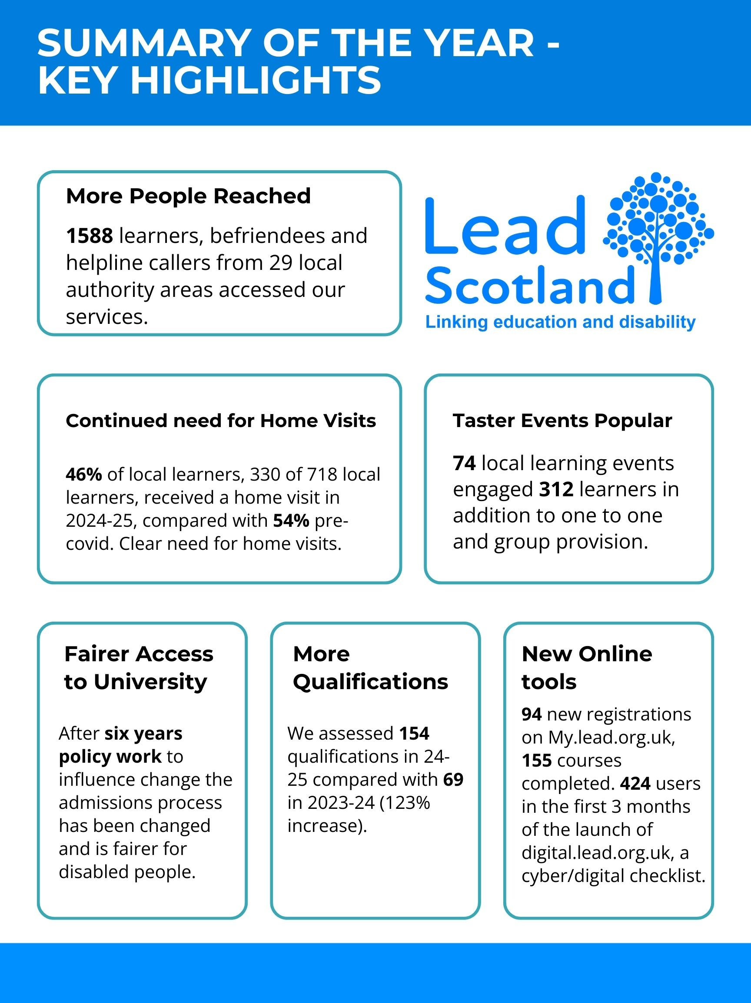

Our Strategic Performance

|  |  |
| --- | --- |
| **Strategic objective** | **Strategic Performance** |
| Increase the number of disabled people and carers progressing with learning and employability skills across Scotland. | We supported 730 local learners up from 585 last year: 368 learners on learning projects and 362 learners on employability projects. Up 25% since last year.  We have undertaken a new Digital Health and Wellbeing project with a research element taking a new approach to evidencing our impact. More Numeracy and Employability contracts delivered more qualifications, 154 up from 69 last year. |
| Increase the take up of remote learning opportunities for disabled people, carers, staff, and volunteers which build confidence and skills. | Most remote learning opportunities are via our national Cyber Scotland project, where we directly engaged 402 learners directly from 27 local authority areas in 2024-25 and more take up of our online digital tools compared with last year. 71 people surveyed said they would cascade learning to a further 1,238 people. 97% people of 71 people surveyed had increased confidence. |
| Extend our befriending services beyond Fife. | Less people are volunteering in Scotland, and like many organisations we are finding it more difficult to attract and retain volunteers. Befriending Coordinators are now directly supporting some befriendees to reduce our dependence on volunteers in our delivery model but we still involve some volunteers who add tremendous value to individuals and projects.  Work has started to develop online volunteer training resources to be hosted on my.lead.org.uk. We are researching the need for a project which combines learning and befriending elements and will seek funding if there is a need for this. |
| Build our capacity to reach more people with our helpline and information services. | Lead Scotland continues to run the only national disabled students’ helpline in Scotland and the learning feeds into our policy. We are more aware of the gap in independent advocacy and representation for young disabled students to resolve complaints with their institution. As the gap continues, we are now seeking funding to extend our helpline to include advocacy. |

## Aberdeenshire, Amy O’Reilly & Danni Phoenix-Kane

### Digital Skills for Health and Wellbeing

**Summary**

This year we were pleased to be funded to run a pilot project through the SCVO Connecting to Care Fund. The project aimed to work with disabled adults and unpaid carers, providing tailored digital skills sessions so that they could better manage their own health and wellbeing outcomes. This included use of the My.Lead.org.uk online learning platform and accredited qualifications.

**Key Stats**

The project was entirely successful with **80** learners receiving support through home visits and group work opportunities. **37** key partners engaged with the service through referrals, partnership working or receiving digital support. This project has provided community members with a wealth of knowledge of online resources including diabetes apps and recipes, tools for supporting their mental health, NHS services, and much more.

**Impact**

Lisa is a lady in her 60s, she heard about us [Lead] through a neighbour and gave me [Learning Coordinator] a call. Lisa has a condition called COPD which means she is mainly housebound as she is on home oxygen. The only time she ventures out is for hospital appointments and relies on patient transport. Lisa had said she only uses her phone for games or social media; she is unsure of how to use it for anything else. Lisa feels isolated and is often home alone. She has recently been diagnosed with type 2 diabetes and is keen to know where to find more information. We looked at NHS inform and read more about type 2 diabetes and COPD. Lisa disclosed she had missed an ophthalmology appointment and didn’t realise how important regular appointments were due to her now having diabetes. After learning more about diabetes she is going to rearrange the appointment. We also looked at chair exercises specifically aimed at those with COPD and Lisa was surprised to see these available online. She wasn’t aware there were exercises designed for doing from a chair. I plan to continue working with Lisa to look at various websites that may increase health and wellbeing as well as build up her confidence in using technology.

* At time of engagement, just 39% of participants agreed or strongly agreed that they were confident in accessing and using digital health services.
* At conclusion of support that figure had improved to **67%** of respondents agreeing or strongly agreeing they were confident.

### Aberdeenshire Employability

**Summary**

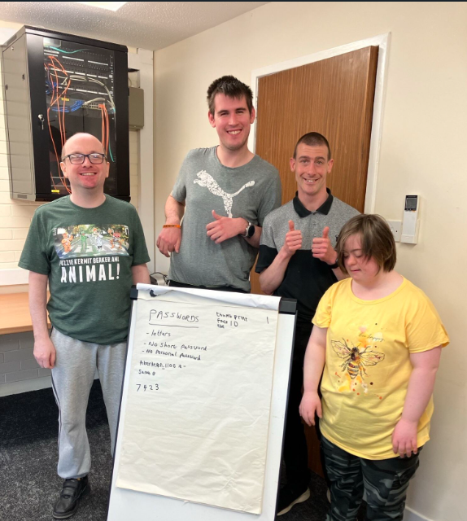Our established Aberdeenshire Employability Project, offering tailored one-to-one and group support to assist learners to enter or resume their path to employment or education, has also seen significant advancement in 2024/25. We entered a partnership with other leading employability providers through **All in Aberdeenshire** (AiA), a strategic partnership focused on facilitating transitions and simplifying access to priority services within the region. We also extended the age range of our provision from 16–24 to 16–67, enabling us to work with far more extensive cohort and respond better to the employability needs of individuals throughout their working life.

**Key stats**

We have supported around **50** learners this year with most receiving one-to-one support provision (including transition support). **20** learners have also achieved qualifications with Lead, with popular options including Steps to Work and Core Skills Numeracy.

* **70%** of participants who responded had sustained their positive destinations **13 weeks** after leaving our service.
* At **26 weeks** this figure was largely maintained, at **67%**

*Impact - how has this project made a difference*

**Matt (name changed):**Matt began working with Lead, having left school without any ongoing support in place. His former careers advisor contacted Lead after hearing about our service operating in the South Shire.

Matt, who has Dyslexia and ADHD, found social interaction difficult and preferred to stay at home. A Learning Coordinator (LC) began meeting with him weekly, using his passion for cars as a basis for building up trust and confidence. These regular conversations helped Matt explore the idea of pursuing work experience in car mechanics at his brother’s garage. This opportunity gave him practical insight, boosted his self-belief, and provided a valuable reference point for his skills.

In addition to working on family vehicles, Matt also engaged with an online community where he and his friends designed car templates. Although he aspired to find paid work in car repairs, his anxiety around social settings made attending college feel out of reach.

To begin building towards his goal, Matt worked with Lead to achieve an SCQF Level 2 unit in Numeracy (Money), marking his first step towards gaining qualifications relevant to mechanics. Completing this unit gave Matt the confidence to start shopping independently—something he previously thought was beyond his capability.

Matt was initially hesitant about to create a CV due to the challenges his Dyslexia caused. In a pivotal moment, the LC shared their own experience of living with Meares-Irlen Syndrome and how they used accessibility tools and overlays to manage reading tasks. This honest exchange helped Matt realise that with the right tools, he too could overcome his barriers. Encouraged by this, he completed his CV using accessibility support and successfully applied for two roles.

A month later, Matt was offered a work experience placement at a garage specialising in car body repairs. Through this experience, Matt has developed skills in diagnosing breakdowns and repairing car panels—progress that not only enhances his confidence but also lays a strong foundation for his future in the automotive industry.

“I have found learning with Lead to be good and I have secured a job with your help, thank you so much” – Learner quote.

**Kelly (name changed):** Kelly began their journey with Lead feeling lost and believing they were a failure. They struggled with low confidence, low self-esteem, dyscalculia, and had little work experience. Completing everyday tasks often felt to be an unachievable endeavour, and setbacks would leave them feeling disheartened.

Kelly achieved the Steps to Work SQA Units 1 and 2 successfully under their LC’s supervision, a major turning point that helped them feel proud of themselves for the first time in a long while. This achievement began to shift their mindset, showing them that they can succeed.

Encouraged by this progress, Kelly continued by achieving a Level 2 qualification in Numeracy and developed their IT skills through a complementary project within Lead. They also expressed a growing interest in public speaking and volunteering and took steps toward these goals.

Kelly actively sought out apprenticeship opportunities and was eager to gain hands-on experience through volunteering. Their confidence has improved immensely: they are willing to travel independently for new opportunities, are keen to learn to drive, and at the time, preparing to apply for ILF funding to support their development.

From feeling directionless to becoming an engaged, self-driven learner, Kelly’s journey so far is a testament to the power of tailored support and personal determination.

“I just wanted to pass this onto you. Yesterday I contacted [Name] for a follow up meeting on how she was getting on with engaging with LEAD. [Name] told me that she has been on a personal journey and how you have supported her every step on the way. [Name] knows now how to improvise which has made life easier for her. [Name] said that you have listened to her, and you ensure that she understands what she has to do. She is happy to continue working towards the modules. [Name] enjoyed her work experience at [Organisation] and feels she has achieved a lot from this experience. I just wanted to let you know that what you do makes a difference.”

Feedback from referrer

### Aberdeenshire Multiply

**Summary**

Launched in 2023/24, the Aberdeenshire Multiply project delivered tailored formal and informal learning opportunities to disabled individuals, unpaid carers, and other individuals facing multiple barriers. The programme aimed to improve numeracy skills, build confidence in basic life skills where numeracy plays a key role, and support progression towards employment or further education.

This work continued into 2024/25, during which we supported **27** learners through both one-to-one and group-based sessions. Some participants achieved accredited outcomes. We collaborated with community groups and utilised local venues to deliver accessible learning. For example, in partnership with Rosehearty Library, we ran themed groups focusing on budgeting, cooking, maths, and digital skills.

**Impact - how has this project made a difference**

**Learner A:** Learner A had previously struggled with formal learning due to learning difficulties and lacked confidence in his numeracy. Motivated by a wish of starting his own car cleaning business, he engaged with the Multiply project to build his skills and confidence.

With a specially tailored support plan, the LC provided one-to-one teaching, such as practical costing exercises. This enabled Learner A to understand how to manage costs and calculate earnings—key components for running a sustainable and successful business.

This personalised approach not only brought him closer to launching his business but also boosted his confidence, potentially leading him to pursue formal numeracy qualifications in the future.

**Comments from learners:**

It has helped me keep up with my son’s maths at school so I can understand and help with homework.

I have had no formal learning before and would like to see where I am before I apply to College.

## Dundee, Amy O’Reilly

The Dundee Project provides general adult learning opportunities for disabled adults and carers. We were delighted to have new Learning Coordinator Rolf Black join the team in July 24. Rolf has worked hard to develop new partnerships and successful referral pathways as well as maintaining long lasting relationships with organisations in Dundee.

**Key stats**

The Learning Coordinator has worked with **38 learners,** providing learners with group work opportunities covering numeracy, literacy, digital skills and cyber security, as well as our vital home visit service, allowing learners who face barriers to accessing support in the community, to learn and grow with Lead.

* **92%** of learners who responded reported increased confidence.
* **89%** of learners reported improved digital skills as one of the barriers to learning removed at the end of their engagement with Lead Scotland.

**Impact**

John (name changed): John was referred to Lead though the disabilities team at the JobCentre+. John indicated he was keen to learn and would like to go to college but had not managed to do this from school for many reasons including lack of support, time keeping, communication barriers, and more. He had tried many other activities, but these had been short lived. This was established in meetings with the learner and both parents, communication with disability support, college and charities the learner has been involved with.

The Learning Coordinator spent some time getting to know John and building up a trusted relationship, encouraging him to talk about his goals. General communication, incl. via email and text was identified as a key factor for previous unsuccessful attempts to join an activity. So, the Learning Coordinator offered some communication training to John involving emailing and texting on iPad and mobile phone. Contact with all previously involved partners and possible new partners (college, etc.) was established to be able to support any communication.

Both learner’s parents were involved, as well as their case worker at JobCentre+, college student support and disability advisors, and other charity workers the learner was involved with.

The Learning Coordinator arranged some new opportunities in the community for John to try. Any planned meetings were accompanied by the learning coordinator to ensure that the learner didn’t miss them (e.g. volunteering in community garden). However, this was not always successful due to barriers previously mentioned.

With the Learning Coordinators support the learner has identified, applied for and accepted a place the Dundee and Angus College. This will hopefully lead to a successful start in taking part in a college course. We will try to identify any issues that could jeopardise this aim and work towards removing these.

### Dundee Multiply

**Summary**

Dundee Multiply started in 23/24, provided tailored formal and informal learning and confidence-building activities to disabled people, unpaid carers and others facing multiple barriers in the local area, helping them improve numeracy skills, build confidence in life skills where numeracy is vital, and open potential progression toward employment or further learning. Following on with the success of doing many accredited group opportunities with partners across Dundee in 23/24, this year (with allocated carry forward) Dundee Multiply saw great success with **12** candidates taking part in accredited qualifications. In partnership with Hillcrest Futures the Learning Coordinator delivered a short series of practical numeracy sessions. Upon completion, the group were invited to complete an Adult Achievement Award to gain accreditation for informal learning they had taken part in, ranging from a SCQF level three up to a level six. While some chose to write about their numeracy learning experience, others wrote about their volunteering, employability pathway and digital learning.

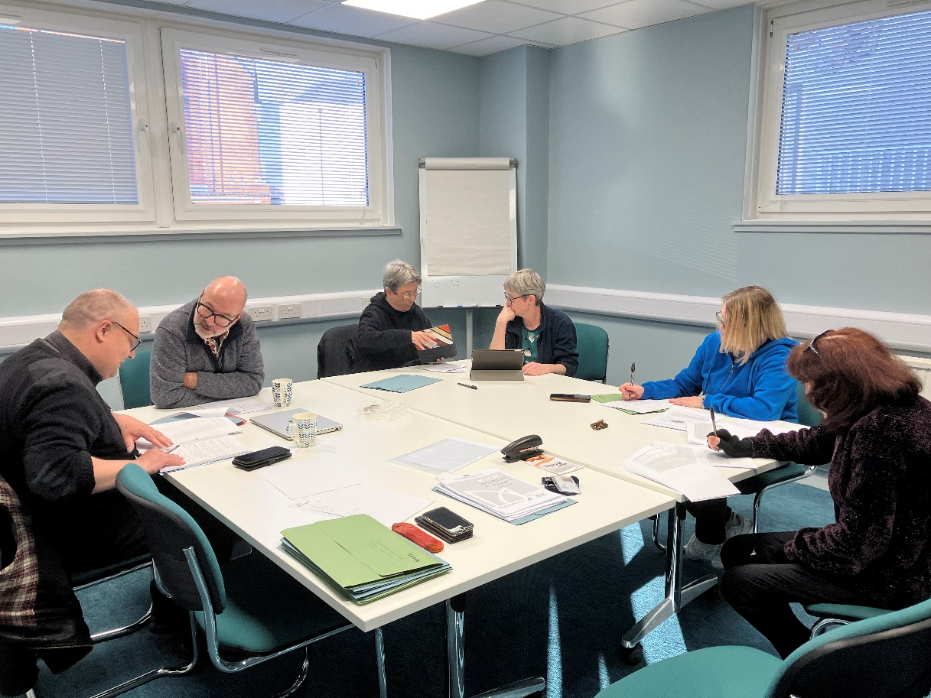

## East Lothian, Danni Phoenix-Kane

### East Lothian Multiply

**Summary**

East Lothian multiply provided tailored formal and informal learning and confidence-building activities to disabled people, unpaid carers and others facing multiple barriers in the local area, helping them improve numeracy skills, build confidence in life skills where numeracy is vital, and open potential progression toward employment or further learning. This project was in its second year, and responding to rising referrals from the previous year, we expanded our capacity to deliver flexible, community based and one-to-one support – delivered by two learning coordinators (combined 63 hours per week) in homes, online and in local settings. Our numeracy pathway reduces anxiety, boosts confidence, and offers accreditation up to SCQF level 4 through enabling and growth activities, including budgeting, digital safety, crafts, cooking and accredited learning. We engaged participants via partnerships with community groups, employability providers, schools, the DWP, and targeted outreach, ensuring inclusive, risk-assessed delivery that meets the needs of those unable to access mainstream learning.

**Key stats**

We engaged with **77** learners over the 24/25 period. This was made up of **57 newly recruited learners** and **20 legacy learners (from 23/24)** during the programme.

We supported **13** adults over 24/25 to gain qualifications, many taking multiple modules to achieve their full Level Numeracy qualification.

*Impact - how has this project made a difference*

**Jenny (name changed):** Jenny aged 16, began her learning journey with Lead feeling extremely shy and reserved, her confidence impacted by difficult academic and social experiences at school. At first, even discussing assessments triggered anxiety and led to cancelled appointments. However, through a strong, supportive relationship with the Learning Coordinator, she has made remarkable personal and academic progress. As her confidence grew, she successfully completed all four SQA Core Skills Numeracy Level 2 assessments. She is also continuing to work towards her Duke of Edinburgh Award, with the Learning Coordinator supporting her in completing the Skills section.

“You were an amazing tutor, and you really helped me and understood how I needed to be taught because of my dyslexia.”

**Edge Group, Musselburgh:** The group was comprised of learners between the ages of 16-21 with a mix of barriers, abilities and experiences. At the beginning of their learning with Lead, many in the group expressed strong negativity towards numeracy, largely due to past school experiences which had resulted in adverse reactions when faced with maths or numbers. Following introductions to the team and Learning Coordinator, reassurance was given that sessions would be engaging and enjoyable, helping to shift these perceptions. It quickly became clear that group collaboration was the most effective approach, allowing learners of varying abilities to support one another. With a focus on budgeting, they worked in small teams to build confidence in handling money and identifying numeracy skills. Through practical, real-life learning, creating their own products and various other activities, the group has improved their understanding of prices and budgeting—key skills that will support greater independence and progress through the transitions programme.

Can we please do the budgeting activity for meals again? That was so much fun! (learner 1) - Yes, please! (learner 2)

**Jamillia (name changed):** Jamilia aged 32, who has a learning disability and experiences anxiety, requires extra time to process information, with repetition and clarification helping her understanding. She had no formal qualifications at service commencement and receives weekly support from ELCAP, as well as guidance from a welfare guardian and social worker. Since beginning her Lead learning journey, Jamilia has made outstanding progress—successfully completing and being awarded her full Numeracy Level 2 qualification. Her confidence has grown significantly, and she used a Samsung tablet provided by Lead to practise daily with maths apps. We continued to stay in touch via text, discussing next steps as she works towards her goal of attending college at Milton Road with support from both us and her social worker. It was a pleasure to support her development and see her ambition grow.

You have helped me to develop my maths skills and be aware how much things cost. When I am shopping with paper notes and coins, I am making sure that I am getting the right change back and if I use my bank card like today, I will use my bank card and check my online banking to check I have not been overcharged by the company I am paying.

I have applied to go to college for life skills or routes into education at Edinburgh College in Milton Road which is easy for me to get to.

## Fife, Amy O’Reilly & Marie Lindsay

### Fife Multiply

***Summary***

Fife multiply provided tailored formal and informal learning and confidence-building activities to disabled people, unpaid carers and others facing multiple barriers in the local area, helping them improve numeracy skills, build confidence in life skills where numeracy is vital, and open potential progression toward employment or further learning. The project was in its second year having started in December 2022. The whole project was delivered by one full-time learning coordinator (35 hours per week). Our numeracy pathway reduces anxiety, boosts confidence, and offers accreditation up to SCQF level 4 (particularly in Core Skills Numeracy and Adult Achievement Awards) through enabling and growth activities, including a developed budgeting and cost of living course, crafts, cooking and life skills.

**Key stats**

In 24/25, we had **25** learners receiving one-to-one or group support and **27** receiving support via Numeracy drop-ins. Also, an estimated **63** participants engaged with community activities such as maths bingo and other interactive events.

*Impact - how has this project made a difference*

**Robert (name changed):** Robert (name changed) was referred to Fife Multiply by Kingdom Housing after witnessing the benefit the project had on another learner. As a resident under Kingdom Housing’s care, Robert faced significant challenges in engaging with and accessing services. His disordered life and offending behaviour were serious stumbling blocks in his life.

At first, Robert was reluctant to participate. He was highly sceptical of the program and did not believe it would suit his needs. However, through consistent relationship-building, we gradually introduced him to engaging, interactive and entertaining numeracy activities. These sessions helped him feel more comfortable and demonstrated that learning could be both fun and rewarding.

As Robert’s confidence grew, we shifted our focus toward gaining SQA qualifications. He aspired to attend college but needed to improve his numeracy skills to meet the entry requirements. Over the following year, he diligently worked through the individual units, ultimately earning his full SQA Level 2 in Numeracy.

Now, with a renewed sense of confidence, Robert prepared and applied to college, feeling ready to navigate the academic environment and take the next step toward his future.

**Learner A:** The project received a referral from Fife Council’s Criminal Justice Department for an older learner. This referral was for an individual that, at the time, was recently released from prison and who was living with the effects of a brain injury that significantly impacted their memory and self-confidence around learning.

To ensure that the process was as accessible as possible, the LC arranged the first meeting at the learner’s own home— a place where they felt comfortable and at ease. By establishing a trusting relationship, the learner slowly began to open up and, with reassurance, was willing to work towards gaining a qualification.

Understanding the challenges posed by the brain injury, the LC adapted their approach to suit the learner- using interactive games and memory aids to facilitate memory recall and retention. This tailored approach proved highly effective, with the learner steadily gaining confidence, and they developed problem-solving strategies and applying techniques learned through Lead Scotland sessions.

With consistent one-to-one support in their home, the learner successfully achieved their qualification—their first in over 40 years.

“I found the project a brilliant help of my memory. I think it is brilliant.”

### Fife Carers Digital Skills

The Fife Adult Carers Digital Skills Project offers support to unpaid carers, over 16, to develop their digital skills, improve their knowledge of cyber security and use their digital skills to better support their caring role. The project also aims to improve the knowledge around digital skills and having a caring role for practitioners from other organisations and sectors.

**Key Stats**

This year, the project welcomed Grant Kidd as the Learning Coordinator for this project. Grant has worked with **48** learners and practitioners with **85%** of learners receiving a home visit and **93%** of learners reporting having gained a new skill that supports their caring role. The project also operates two drop-in provisions, one with Alzheimer Scotland Fife Dementia Resource Centre, Kirkcaldy and Nourish Community Hub, Kirkcaldy.

**Impact**

One learner commented “Grant and Lead Scotland loaned me an iPad which has changed my life, I would never have been able to afford one as I’m on Universal Credit. Grant is helping me learn how to use it and has taught me things like how to make a strong password and how to download and use apps like Facebook”.

Another Learner commented “My Blue Badge had run out, Grant helped me renew it online through Fife Council’s website. He even showed me how to take a picture of my driving licence and send it to them, so I didn't need to go to the council offices, which meant I got my new badge quicker”.

John has managed to set up a What’s App group chat with his Grandchildren which he really enjoys. He told me “It’s great being able to speak to them regularly as they live all over Britain, they can tell me what they are doing at school, one of them now even calls me ‘cool Granddad’ which is great!”

Mary has also made a lot of progress and has started shopping online for groceries with ASDA. She commented “shopping online is so much more convenient as John, and I are not always able to get to ASDA’s due to poor health”, she also stated that “there is a wider selection and lower prices which is great. I wouldn’t have been able to shop online without Grants help and patience, I’m looking forward to learning more”.

### Fife Adult Learning

Our Fife Adult Learning Project offers tailored informal and formal learning opportunities to disabled adults in the community and at home. This year learners have undertaken topics including, numeracy, literacy, digital skills and cyber security, communications and more. The learning is delivered by our dedicated Learning Coordinator and a team of passionate volunteers.

**Key Stats**

Our ability to provide homes visits is something that Lead is passionate about as an organisation. This breaks barriers that many disabled adults face to accessing education in Scotland such as poor transport links, rural populations, mobility and ill health. Our Fife project saw **89%** of learners receive a home learning session, with **100%** of learners identifying they had overcome at least one barrier to learning they face at the beginning of their journey with Lead.

**Impact**

James (name changed), a middle-aged male, was a first-time learner with a history of negative experiences in education and multiple incarcerations. Upon release, his social worker reached out to Lead Scotland, seeking learning opportunities for him. James expressed a desire to develop his literacy skills, as he struggled with reading and writing, particularly with understanding and responding to letters.

Matched with an experienced volunteer, James began learning the alphabet and spelling simple words. They progressed to grammar, sentence formation, and reading practice. Practical tasks, such as creating shopping lists for the supermarket, helped James connect his learning to everyday life. He also began writing a journal, reflecting on his personal journey and experiences with Lead Scotland. Over time, James made remarkable progress. He gained the confidence to read and respond to letters independently, a milestone that had a significant impact on his life. One memorable moment was when he successfully read the lyrics at a karaoke session with friends—something he had once feared due to his literacy challenges. James reflected on his journey, saying, **"Before I didn’t even know the alphabet. Now, I can write sentences and paragraphs, and I can read my own letters instead of asking my 90-year-old mother. Lead Scotland has changed my life."**

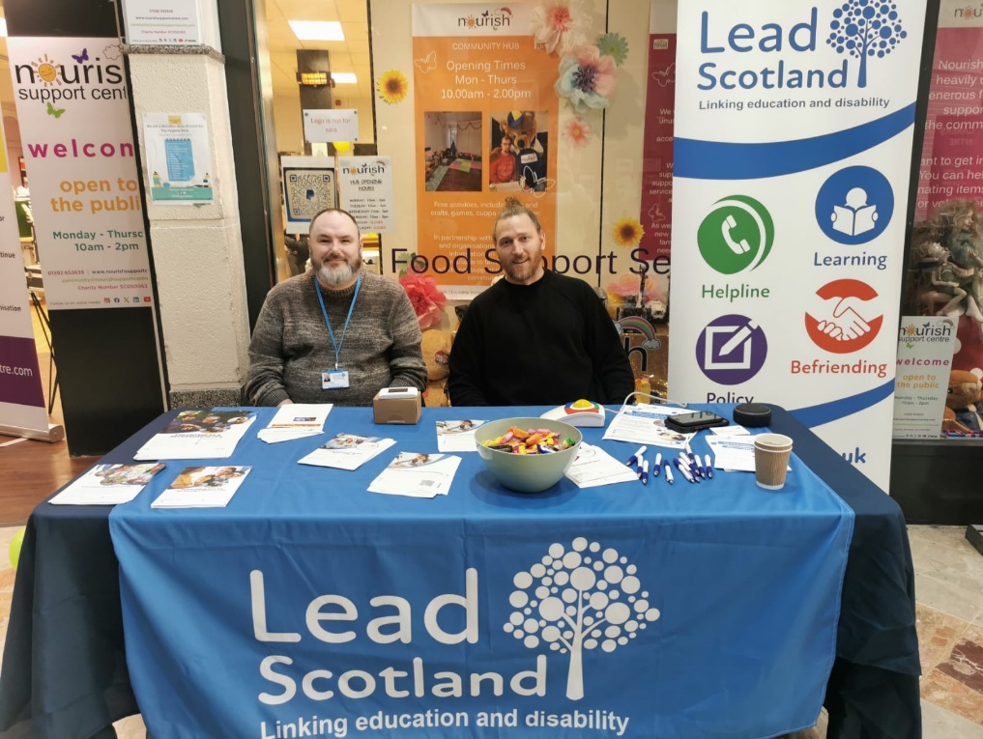James has returned to the FALP waitlist to work towards an Adult Achievement Award. In the meantime, he’s volunteering in a garden group and continues to use the skills he gained daily. His volunteer mentor shared, **"When I first met James, he couldn’t even recite the alphabet. Now, he’s confident enough to sing at karaoke, read at Level 3, and write sentences and paragraphs. It’s been an honour to see his transformation."**

**Photo: Our Fife Learning Coordinators Liam and Grant attending an information day for unpaid carers**

FIFE BEFRIENDING PROJECTS

Lead Scotland has two Befriending Projects in Fife to support individuals who experience isolation and loneliness: **Fife Adult Befriending** and **Fife Young Carers Befriending.** By providing short-term, outcome focussed befriending support for up to 6 months, we foster improved confidence, well-being and stronger community connections which helps sustain increased engagement and activities beyond the befriending period.

We welcomed 4 new part-time staff to the Befriending Team this year: Marie (Befriending Services Manager - Nov 24), Kirstyn (Adult Befriending Coordinator - Oct 24), Natasha (Young Carers Befriending Coordinator - Nov 24), Judith (Young Carers Befriending Coordinator - Jan 25).

Our fantastic team of Befriending Coordinators and Volunteer Befrienders support our participants to build confidence and connect more with their communities. Our Befriending Coordinators can directly support befriendees to meet increased demand for services, enhance our service delivery model and reduce our dependence on volunteers. We know that between 2019-2023, 335,000 (8%) less people are volunteering (Scottish Household Survey 2023), and many third sector groups are facing a crisis with volunteer recruitment and retention therefore we have adapted our service model with staff having a caseload of befriendees as well as involving volunteers.

**Training and Continuing Personal Development for Staff and Volunteer**s

* We developed and presented new in-person and online training sessions to enhance the volunteer’s skills: induction/refresher, lone volunteering, boundaries and adult support and protection.
* Our staff attended Fife Council’s Virtual Learning Environment (VLE): Adult Support & Protection Awareness, CPC GIRFEC & Child Protection, Coach Approach, Dementia Awareness, Epilepsy Awareness.
* Fife Council GDPR training.
* Our staff attended DeafBlind and DeafBlind Champion Awareness in February. We developed a comprehensive training resource for staff and volunteers on DeafBlindness and Sighted Guide Training and are liaising with DeafBlind Scotland to endorse it.
* Our staff continue to complete the Fife Voluntary Action Volunteer Management Course (6 sessions).
* We continue to access any training opportunities through Fife Council, Fife Voluntary Action, Befriending Networks, Volunteer Scotland, NHS Health Promotion Fife and relevant training from our networks.

**Befriending/Volunteering Networking -** We wish to highlight our continued involvement with various quarterly forums and annual conferences to enhance collaboration and advocate for the needs of our service users. We also conducted five volunteer recruitment events during the Spring period when the motivation to volunteer is at its highest. These activities provided valuable opportunities to share insights, strengthen partnerships, highlight the work that we do and how to get involved. Our highlights include:

* **Befriending Forum**: Sharing best practices in volunteer recruitment and retention, looking at training and contributing to sector-wide improvements.
* **Carers Forum**: Collaborating with the network to develop services and resources tailored to carers' needs.
* **Equalities Forum**: Advocating for inclusive practices to ensure accessibility for all participants.
* **Health and Social Care Forum**: sharing the impact of befriending on reducing social isolation and improving mental health and engagement.
* **Mental Health Forum**: Highlighting the role of befriending in promoting mental well-being.
* **Social Isolation & Loneliness Forum**: Exploring strategies to address loneliness through community-based initiatives.
* **Volunteer Managers Forum**: Discussing innovative approaches to volunteer engagement and recognition.
* **Befriending Networks** - Journey Across Befriending Roadshow in Glasgow – networking with our colleagues across Scotland.
* **College Moving On Events** x 2 (Dunfermline/Glenothes) to attract new applicants and referrals to the services.
* **CYPFEIF & ALEC Fund and CYPFAL** Third Sector Fund - 2025 Conference in Edinburgh – networking and workshops eg: AI, Volunteer Recruitment.
* **Volunteer Recruitment Roadshows** x 5 (Dunfermline/Glenrothes/Cupar/ Kirkcaldy/Cowdenbeath).
* **The FORT System** – We are now registered on The Fife Online Referral and Tracking (FORT) system.

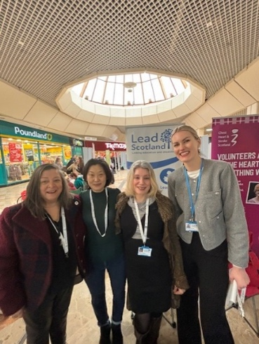

Photo: **Kirstyn, Natasha at Fife Voluntary Action’s Kirkcaldy Volunteer Recruitment Roadshow – February 2025**

### Fife Adult Befriending Project

#### **Summary**

Lead Scotland’s Fife Adult Befriending Project is a service for adults and older people in Fife who feel isolated, lonely or disconnected, perhaps because of disability, ill health or other circumstances. The project is coordinated by one part-time Befriending Coordinator, supported by a team of volunteers, who provide befriending support from 1-3 hours per week, up to six months’ duration.

#### **Key Stats**

Kirstyn was recruited as Fife Adult Befriending Coordinator in October 2024 (moving from Young Carers). Our key achievements include:

* We supported 25 befriendees on a one-to-one basis, fostering trusting, meaningful and enduring relationships and activities.
* We engaged with over 100 befriendees: 33 are on the waiting list, (plus 5 more in April 25), 55 were sent information, 5 were signposted to other organisations, 7 were interested in volunteering, and 7 withdrew.
* We supported our befriendees to access local community-based activities, e.g.: walks, café, shopping or attending activities together.
* We engaged with 31 volunteers during this time and supported them through application, recruitment, PVG and training both online and in person.
* We attended various forums, networking events, recruitment roadshows and college events to attract new applicants and referrals to the services (see (Befriending/Volunteering Networking section above).
* We met Lecturers and Social Science Students at Fife College Glenrothes to offer them valuable volunteering opportunities which contributes to their experience and is beneficial for any future education/work applications.
* We delivered presentations in person/teams with the Adult Social Work and Fife Forum Departments who support the needs of older people and adults.
* We engaged with over **100** befriendees **and 31** volunteers in 2024/25

#### **Impact**

**Case Study** - Duncan (middle aged) is unemployed, living alone, with a brain injury and is currently being supported by retired teacher Winnie (60’s). Duncan has experienced a great deal of loneliness and isolation since relocating to another town within Fife away from his hometown. During the first month of the befriending match, they spent time getting to know each other by going on local walks and to the local cafe together. Duncan said that he enjoys playing snooker and they are now going to their local Sports Bar and Snooker Club. Duncan is getting to know many others who also enjoy playing snooker and he’ll be ‘lining’ up to meet them after the befriending ends.

‘I really enjoy spending time with Winnie and getting involved with new local activities. I feel much better for having a healthier pursuit and getting to know like-minded people.’ Duncan, Befriendee

### Fife Young Carer Befriending Project

#### **Summary**

Lead Scotland’s Fife Young Carers Befriending Project is a service for young people aged between 12 to 18 years’ of age who have a caring role at home in Fife to enable them to experience the same opportunities as their peers and offer them much-needed respite from their caring responsibilities. The project is coordinated by two part-time Befriending Coordinators, supported by a team of volunteers. The befriending support is from 1-3 hours per week for a duration of up to 6 months.

#### **Key Stats**

We employed 2 new Young Carers Befriending Coordinators: Natasha (Nov 24) and Judith (Jan 25). Our key achievements include:

* We worked with 34 young people and involved 23 volunteers with the project and we also invited them to take part in our Community Litter Pick Event - fostering trusting, meaningful and enduring relationships and activities.

A group of lead Scotland and Fife Young Carers staff standing smiling in front of a green wall with plants and the Fife Young Carers sign.
**Photo** – Judith, Sara, Marie, Natasha and Jodie, Fife Young Carers & Lead Scotland Partnership.

* We enabled our young people to achieve their individual goals, such as participating in extracurricular activities, developing new skills, building stronger relationships and increasing their confidence, eg; walks, cafe, groups, events.
* One young carer had a special one-off trip to the Edinburgh Dungeons, something she always wanted to do and even got into character/dressed up for the occasion!
* Our young people are then referred to Fife Young Carers to attend their group sessions, or for a Young Carers Statement which acts as a bridge to other community supports and funding. They are also signposted to sporting or other groups/clubs or volunteering.
* We organised Community Litter Picks including the most recent one at Raith Rovers in April where they attended the match, met the players and cleared up the stands afterwards.
* We continued regular engagement with local high schools to identify and support young carers in need, meeting with teachers and guidance staff.
* We attended various forums, networking events, recruitment roadshows and college events to attract new applicants and referrals to the services (see (Befriending/Volunteering Networking section above).
* We strengthened our partnership agreement with Fife Young Carers, joined up the new teams and updated our Partnership Agreement.

#### **Impact**

**Case Study-- A Befriending Journey of Trust and Creativity** *By Natasha Brodie, Befriending Coordinator – Lead Scotland Young Carers Project*

**Introduction –** Alice, a creative and thoughtful young carer, was matched with Rab, one of our dedicated volunteers. Six weeks into their befriending journey, their connection is making a meaningful difference in her confidence and wellbeing.

**Building Trust and Connection -** From early on, Alice and Rab built a strong rapport. A quiet but significant moment occurred when Alice invited Rab into her new home before one of their outings—an early sign of growing trust. Alice described Rab as respectful and kind and highlighted how their time together gives her space away from caregiving responsibilities. She feels safe and supported, and looks forward to exploring new interests like art, crochet, and historical landscapes.

“Time with my befriender has made me feel better, as I'm getting more social interaction than staying inside all the time.” Alice, Befriendee

**Shared Activities and Adventures –** Rab has tailored each session to reflect Alice’s interests, particularly her love for history and immersive experiences. So far, their outings have included:

* A visit to the Edinburgh Dungeon, where Alice embraced full costume and character play.
* An afternoon at Adventure Golf Island in Dunfermline.
* A walk along Pathhead Sands and exploration of Ravenscraig Castle.
* A bowling session, which Alice found soothing and fun.
* A visit to the Witch Trials Museum, which she now wants to revisit for a more interactive experience.
* A person wearing a black robe and a black hat dressed as a witch

  Planned activities include returning to the Dungeon and attending the fair at Warout.

“I do feel we are at ease with each other and the rapport is great. I feel supported in my role, and I value the guidance provided.” Rab, Volunteer

**Conclusion -** This befriending relationship highlights the power of consistency, creativity, and genuine connection. Rab takes a relaxed, thoughtful approach that keeps Alice’s energy and preferences at the heart of each session. Alice is growing more confident, engaged, and expressive - it’s a privilege to support her journey.

‘I just wanted to take a moment to say how genuinely in awe I am of you and everything you do. The kindness, encouragement, and genuine care you show are something truly special—and I feel lucky every day that you’re part of our Lead Befriending Team’. Natasha, Befriending Coordinator

**Championship Goal at the Litter Pick!**

Our successful Community Litter Pick at Raith Rovers involved befriendees, volunteers, and staff where we all watched the game, enjoyed food and refreshments, met Councillor Judy Hamilton, ‘celebrated the Championship Goal 1-0 to Raith vs Ayr’, met the football players (with signed footballs and t-shirts) and, at the end of the match, we cleared up one side of the stadium. One young person has since joined the Raith Rovers Community Foundation to participate in the young person’s weekly football sessions.

**Picture** Courtesy of RRFC - Staff, Volunteers, Young People and RRFC Officials Line Up before the Raith Rovers vs Ayr Championship Match – 5 April 2025



**Picture –** Community Litter Pick at Raith Rovers Football Ground – 5 April 2025

#### **Conclusion**

The period since November has been marked by significant progress in establishing a new team whose collective experience and dedication strengthens our drive to achieving our befriending outcomes. We have been reengaging with all our networks to introduce all our new befriending team staff. In moving forward, we endeavour to maintain and extend our reach to engage with the people who need us most. We will continue to advocate for the needs of our service users. We will further enhance and transition our volunteer training onto Lead’s online learning platform.

## Highland, Danni Phoenix-Kane

### Highland Multiply

**Summary**

Highland multiply provided tailored formal and informal learning and confidence-building activities to disabled people, unpaid carers and others facing multiple barriers in the local area, helping them improve numeracy skills, build confidence in life skills where numeracy is vital, and open potential progression toward employment or further learning. The project continued from two previous quarters the year before (Q3 and Q4), which to that point engaged with **23** one-to-one learners and **13** within group work. 24/25 was a bumper year for the service which concluded end of February 2025. The whole project was delivered by one full-time learning coordinator (35 hours per week). Our numeracy pathway reduces anxiety, boosts confidence, and offers accreditation up to SCQF level 4 (particularly in Core Skills Numeracy and Adult Achievement Awards) through enabling and growth activities, including budgeting, art projects, cooking and life skills. Lead engaged participants via partnerships with community groups (such as Flip of the Coin, Brora Learning Centre, Home-Start Highland) and targeted outreach, ensuring inclusive, risk-assessed delivery that meets the needs of those unable to access mainstream learning.

**Key stats**

In 24/25, **86 learners** were uniquely recruited: **21 learners** receiving one-to-one support and **65 learners** receiving group support. Over the lifespan of the project (including 23/24 Q3 and Q4) this has meant **44 learners** received one-to-one support (including **10 legacy learners** from the previous year) and **78 learners** received support via group work.

* Over the lifespan of the service a total of **12 SQAs** and **13 Adult Achievement Award** qualifications were completed.

**Impact - how has this project made a difference**

Learner A: Learner A was referred for 1:1 support to improve money management and budgeting skills after a change in their family circumstances as a single parent with young children. Over the course of 12 months, they engaged with the service to build core numeracy skills, particularly as they had been diagnosed with dyscalculia and had faced lifelong challenges in this area.

Concerned about maintaining employment due to their changing circumstances, the Learning Coordinator started by focusing on practical money management strategies. This included creating a monthly budget plan to cover essential expenses and childcare costs. Alongside this, we worked on basic addition and subtraction skills, leading to ‘A’ successfully achieving an SQA qualification in numeracy.

During the sessions, ‘A’ expressed an interest in career progression. With little work available and only being able to work one day per week had made career progression difficult. To support this goal, we continued developing their numeracy skills while also teaching basic ICT skills to enhance their employability further.

Recognising their ambitions, we facilitated a referral for employability support, and ‘A’ is now actively working with an employability service to apply for a health visitor training programme. They had at the time, also successfully maintained their current employment, demonstrating both resilience and commitment to their future career development.

**Learner B:** Learner B was referred via The Community Link Worker service having faced multiple barriers to progression including over 10 years of unemployment and a disability. We began by exploring these barriers to progression using a solution focused approach to ensure there was a strong foundation for learning. This involved B developing core numeracy skills to include the completion of a SQA Numeracy Calculations Level 3 which enabled them to create a financial plan, monthly budget plan and time management plan.

Through this work we were then able to identify opportunities to develop skills further through volunteering. This volunteering opportunity has now led to learner ‘B’ being offered a paid training placement for 6 months with support to obtain permanent employment.

‘I am more independent now and feel more confident in managing my finances and I can keep myself safe with money, my number skills have increased, and I really liked working with the service, I am looking forward to my new job and excited to have a job title’.

**Feedback from referrers:**

WOW! That is a really impressive turnaround I am blown away not just by what Newbattle [Accreditation authority of AAAs] can achieve but your time and effort with this group, I am so pleased it has actually come to fruition as I think it has given them a real boost. We will look at getting a date arranged for a celebration **(Voluntary Action Lochaber)**

I would like to thank you for your support and amazing service which was very beneficial.

Lynn Doherty from Lead Scotland (Multiply project) has supported 17 of Home-Start families this year. Lynn offered group and one-to-one support. Her work is invaluable. She helped our families with budgeting, finances, filling the forms, cooking skills, gaining access to education and qualifications and many more. She provided great service and boosted confidence of our families. It was always a pleasure to work with Lynn as she is very accommodating, and her creative ideas helped people engage in the service. I hope we will be able to referrer more families to the service. **(Home-Start East Highland)**

**Numeracy Skills for Life Online Project**

**Summary**

With support from Highland UKSPF funding, and as part of our commitment to creating a legacy from the Multiply programme, we developed a suite of numeracy resources specifically designed for disabled people and unpaid carers. These resources support both self-directed and supported learning through our accessible online platform, **my.lead.org.uk**.

Building on our existing catalogue of free short courses in cyber safety and digital accessibility, we expanded our offering to include numeracy-focused content. Learners in Highland were actively involved in testing these courses during development, helping to shape their accessibility and effectiveness.

Our approach was centred on reducing numeracy anxiety and fostering practical, real-world skills. As part of this work, we created five online numeracy courses aligned with the unit requirements for **SQA Level 2 Core Skills in Numeracy**. These can be used for independent study or as guided learning resources to help learners prepare to undertake formal assessments.

To date, these courses have been completed 15 times with “Numeracy: Time” and “Graphical Information” being the most popular courses.

* **Numeracy: Measuring skills (level 2**) “Excellent course on measuring at this level for using weighing scales.”
* **Numeracy: Graphical information (level 2)** “Great course on everyday uses and skills needed to read and interpret graphical information.”

## Moray, Danni Phoenix-Kane

### Moray Multiply

**Summary**

Moray Multiply provided tailored formal and informal learning and confidence-building activities to disabled people, unpaid carers and others facing multiple barriers in the local area, helping them improve numeracy skills, build confidence in life skills where numeracy is vital, and open potential progression toward employment or further learning. The project was a continuation from 23/24, and many learners received intensive and ongoing support across the lifespan of the project. The whole project was delivered by one full-time learning coordinator (35 hours per week). Our numeracy pathway reduces anxiety, boosts confidence, and offers accreditation up to SCQF level 4 (particularly in Core Skills Numeracy and Adult Achievement Awards) through enabling and growth activities, including budgeting, travel training, crafts, cooking, performance and storytelling and life skills. Moray Multiply also ran many community events such as escape rooms, maths bingo and holiday season craft sessions to engage the local community in numeracy.

*Key stats*

In 2024/25, **24** learners received one-to-one support, with some gaining the confidence to participate in group sessions for the first time. In addition, **184** individuals engaged with numeracy drop-in sessions and other events delivered by the project. Notably, **14** learners successfully completed an accredited qualification.

* **100%** of learners who responded to our request for feedback got the numeracy support they were seeking and understood their options for further learning.
* **89%** of learners achieved their goals and were feeling positive and motivated to continue learning.
* **63%** felt more confident with numbers.
* **53%** were less worried about understanding living costs.
* **43%** got the digital support they were seeking to use online numeracy tools

*Impact - how has this project made a difference*

**Learner 1:** The learner expressed a strong desire to become more independent, particularly in traveling alone to Elgin for shopping and visiting local coffee shops. With support from Lead, they gradually built confidence by using M Connect and Stagecoach buses on multiple occasions. Over time, they successfully learned to navigate the journey independently, eventually meeting their Learning Coordinator (LC) at a coffee shop in Elgin and returning home on their own by bus.

In addition to developing their travel skills, the learner also volunteers at a local charity shop and aimed to build confidence in handling cash. The LC provided ongoing support over several weeks, helping them practice and improve their skills. As a result, the learner is now able to confidently provide accurate change from a £20.00 note—something they previously found challenging. To support their continued progress, they have also purchased a calculator to use at the till, enabling them to manage transactions with greater ease.

“I love being able to get the bus on my own now, all the way to Elgin! I am planning on going to the cinema next week.”

**Learner 2:** This learner has made significant progress since first meeting the LC. They have moved back home and are actively engaged in Open University courses while awaiting the start of their next program at UHI: the COSCA Certificate in Counselling Skills (SCQF Level 8) CPD Award.

They are enthusiastic about beginning this new course and have plans to pursue an undergraduate degree afterward.

Additionally, the learner successfully completed the F3GJ 08 – Time Unit, to which this completion allowed the achievement of the full qualification - SQA Core Skills Level 2 Numeracy F3GF 08.

With the LC's support, the learner also attended a Scottish Parliamentary reception in Edinburgh, where they contributed to a presentation on the transitional gaps in education.

“This time last year, I never thought I would be confident enough to speak in Scottish Parliament in front of lots of people like this. Thank you so much!”

**DnD campaign (showcased by National Numeracy):**

Lead Scotland embarked on a Dungeons & Dragons–style adventure with participants set in a fantastical version of Scotland, with the goal of developing teamwork, communication, creativity, and fun. Through interactive narrative storytelling and role-play, adventurers conquered challenges like negotiation, puzzle-solving, and combat, all in a quest to free a frozen wizard and restoring harmony to the multiverse.

Players created their own unique characters and collaborated with a Games Master to shape a dynamic, player-led narrative. Carefully designed puzzles, aligned with SQA Assessment Levels, offered an engaging way to strengthen core numeracy skills in an enjoyable, memorable context.

The experience reached its pinnacle with an in-person finale—an especially meaningful milestone for those who had never worked in a group setting before—highlighting the transformative power of imagination and collaboration to overcome perceived barriers.

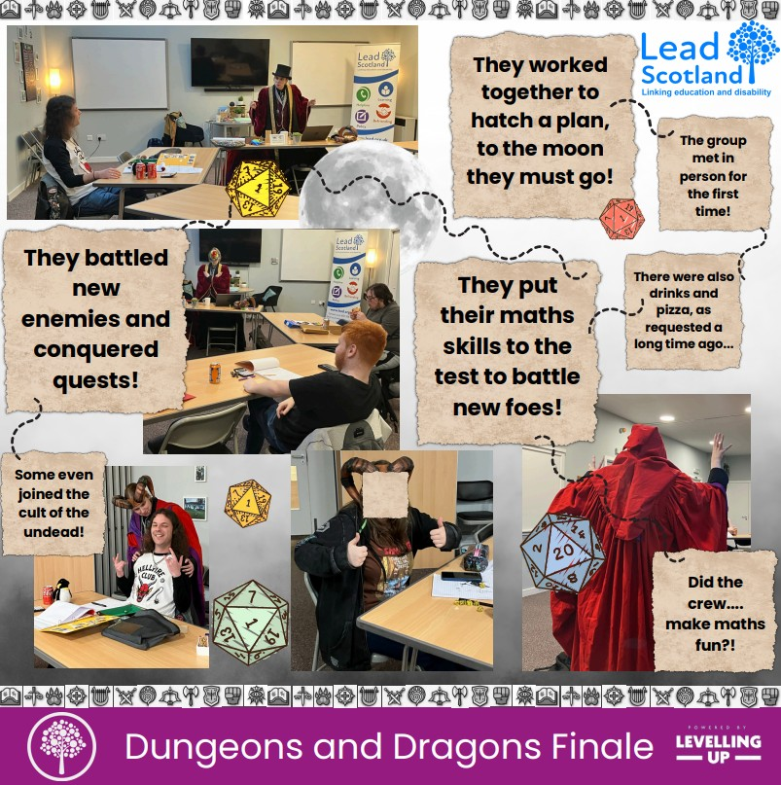

**Learner quotes:**

“I had so much fun! It was ace. You hid the maths really well; I want to set up my own DnD group!”

“You lose yourself in the story and forget you’re doing calculations of the dice and figure out the maths questions, it’s really built my confidence.”

## Perth and Kinross, Amy O’Reilly

**Perth and Kinross Digital Skills**

**Perth and Kinross digital skills project** provides bespoke digital learning opportunities for those facing a barrier to learning. This project strives to improve the digital confidence of the people of Perth in Kinross, improving their knowledge and access to online services and information. This can be life changing when living in a rural community as many do in Perth and Kinross.

**Key Stats**

In 24/25 the Perth project supported **64** people with their digital skills, of whom **86%** received a home visit and **100%** reported increased digital confidence as a direct result of Lead Scotland involvement.

**Impact – Case Study**

I have worked with a visually impaired learner, Linda (name changed), who was referred to us by a partner organisation. She has diabetes and was looking for some technology to help read her blood glucose level out loud. Linda had previously been visited by a different Lead Learning Coordinator who suggested a scanning smart pen to read the blood glucose level out loud from the monitor. I took this device to Linda to try. I gave her a tutorial on the device and some guidance while she was trying to use it, but it was proving too difficult, due to a tremor in her hands, and the fact that the pen needed to be held across the writing on the monitor at the correct orientation. We went back to the drawing board and discussed some other options together.

Linda decided she would be willing to try a smart phone and use the app that goes along with the device she wears on her arm. We decided she could try using the app along with my iPhone to see if this felt like an option, before committing to buying one herself. I enabled the Voice Over accessibility feature, downloaded the app, got Linda signed in and then gave her a tutorial on how she could use the app to read her blood glucose level out loud. After a couple of trials, she felt like this would be a solution to her issue and felt that acquiring a second-hand/older model of an iPhone would be appropriate.

I contacted her brother, who had offered to help with this process, to explain what Linda was looking for, and he purchased an iPhone for her. Since then, I have had a couple of home visits with Linda and her siblings to give tutorials on using the blood glucose monitoring app, the accessibility features of the iPhone, like Guided Access and Voice Over, and other supportive apps to assist with visual impairments. There has been lots of trial and error, as some processes are easier than others and it can take lots of practice, but we are on our way to getting Linda able to access her blood glucose readings independently.

**Comments by our learners:**

“The Learning Coordinator has been very helpful and very patient with a senior citizen. I have learned to look into my Ovo account and online banking account independently. The support has been very helpful in lots of ways. The LC helped me to shop online and set up a video doorbell which has helped me to stay independent in my own home. When apps change or update, I really need the support of the LC as I’m a senior citizen. You’re a real support.”

**“The learning support has improved my confidence and given me new ideas and things to work on. Improving the settings on my device has improved things for me. You've answered all my digital questions I have. It's helped me with making decisions about what I do online. I love Canva! I feel more confident with using the internet and making choices about what websites to visit. I'm not afraid to try things anymore. I feel your communication skills are excellent. You're very knowledgeable and very good at explanations.”**

“I learned a great deal in our time together and now have the confidence to fully explore my computer and mobile phone. If there is anything I am unsure about I know I can find an answer on the Internet. I might have to change my wording a few times, but I know the answer is there somewhere. I enjoyed our sessions, and the Learning Coordinator was very good at putting me at ease. ”

“In terms of LEAD Scotland's service - the flexibility to go on with someone who can't manage very well with the digital age is vital and that is what I have had. I've learned a lot but have difficulty keeping things in my mind because my short-term memory is not working properly; this is because of 40 years of mental health problems. Also, some technical things are just too difficult e.g. copy and paste. I really appreciate LEAD's support; I don't think I could keep going without this support.”

### Perth and Kinross Tenants Project

Perth and Kinross Tenants Project was created to support council tenants to participate and engage with the housing service digitally, to improve digital inclusion within this community and to provide digital enabling skills, supporting tenants who experience barriers to participation and who are digitally excluded.

The learning coordinator delivered a range of tailored approaches for digital inclusion support for tenants, based on their skills and needs (in person or online, in groups, or advice by phone. While this involved improving general digital confidence, it also included ensuring tenants could have a say, be involved in self-assessment and scrutiny of the Housing Service through online means. To futher reduce digital exclusion, the project was able to provide learners with tablets and access to data if they required this.

**Key Stats**

In 24/25 the project supported **90** tenants to become digitally included, with **95%** of those receiving digital upskilling reporting an increase in their confidence. We were delighted to take part in several great opportunities this year including the PKC CLD Inspection Focus Group (attended alongside the PKC Tenant and Resident Participation Team), a Double Dykes drop-in information session for the travelling community (run alongside the PKC Tenant and Resident Participation Team) and the commencement of the Crieff Digital Skills Group. We were also delighted for the project, alongside the inclusion working being done by the PKC Tenant and Resident Participation Team, to win the award for the Widening Engagement category for Digital Inclusion at the TPAS Scotland National Good Practice Awards.

**Case Study**

One gentleman had been visited by the learning coordinator previously and learning how to face-time family members and use Facebook. It initially seemed that he was happy with this level of knowledge but a follow up indicated he would benefit from more digital skills opportunities.

He disclosed he was concerned about an upcoming trip to Ninewells hospital in Dundee. We covered the trip, first setting up google maps. His ‘home’ was set to a crematorium in Fife. This caused some amusement, “I’m not dead yet!”. The learning coordinator soon showed the learner how to remedy this and by the end of the session he could plan routes back simply by saying ‘home’. Then we looked at street views to ensure we had the correct location. He was delighted and relieved – taking a great deal of strain off the stress of having to attend appointments at such a large hospital.

**Comments by Tenants**

I have learned how to do online banking and online shopping. I am feeling more confident with how to do things. I don't need to bother other folk to ask them."

"The learning coordinator knows what they're talking about. I am quite happy with everything to be honest with you."

**“This has changed my life. I feel as if I’m achieving something. I’ve learned how to online shopping and be more independent. I search for and learn about things that interest me. It’s opened a new way of life for me. I love learning. I wish I had had the opportunity when I was younger. It’s sad as I always thought I couldn’t achieve anything. I have struggled with some health concerns, but I really try and keep going with my learning. If I didn’t then I would have nothing to look forward to.”**

That’s amazing, I can see it now, I couldn’t before.” (Increasing font size and providing assistance)

“That’s been so helpful thank you!’

“Oh you are good to me!”

“The meeting (zoom) went brilliantly. Thank you for helping us out.”

## North Lanarkshire, Amy O’Reilly

**North Lanarkshire Adult Learning** offers a diverse range of tailored learning opportunities, delivered by our dedicated Learning Coordinator and a team of passionate volunteers. These opportunities include support with numeracy, literacy, confidence building, employability skills, and access to accreditation.

A key element of the project is our home learning provision, which is essential for learners facing barriers to accessing traditional community services. This flexible approach enables individuals to build confidence in a safe and supportive environment. As a result, many go on to engage in community-based opportunities such as college courses, volunteering, and employment.

*Impact*

One such learner, *Jordan* (name changed), a young adult, has been participating since September 2024 with the aim of improving his literacy and building his confidence. With support from the Learning Coordinator, Jordan has worked through tailored worksheets to identify both his strengths and areas for development. Notably, he successfully read Mary Shelley's *Frankenstein* as part of his learning journey. To formally recognise his progress, the Learning Coordinator has encouraged Jordan to undertake the Adult Achievement Award—a context-free qualification that accredits informal learning.

In addition to one-to-one support, North Lanarkshire Adult Learning runs popular group sessions in partnership with DWP Cumbernauld. These sessions focus on enhancing digital skills for job seekers, covering topics such as job applications, CV building and updating, setting up and using email, and understanding cyber security. Although attendees have varying levels of digital confidence, shared challenges often lead to valuable peer support. Each session includes a Q&A segment, hosted by the Learning Coordinator, which encourages discussion, troubleshooting, and the development of future topics.

Many participants report a boost in digital confidence and go on to pursue employment or further education, including courses at South Lanarkshire College.

## Scotland wide Cyber project, Michael Chamberlain-Cove

Our Scotland-wide Cyber project – Linking Cyber and Accessibility – has been running since March 2020 and aims to reduce the knowledge and skills gap many disabled people face when it comes to staying safe online. The project runs over five key strands: creating accessible resources and guides, running accessible training workshops, creating accessible self-study courses on our online learning platform my.lead.org.uk, running formal cyber resilience qualifications, and working in partnership with key organisations to help advocate for and improve digital inclusion and accessibility.

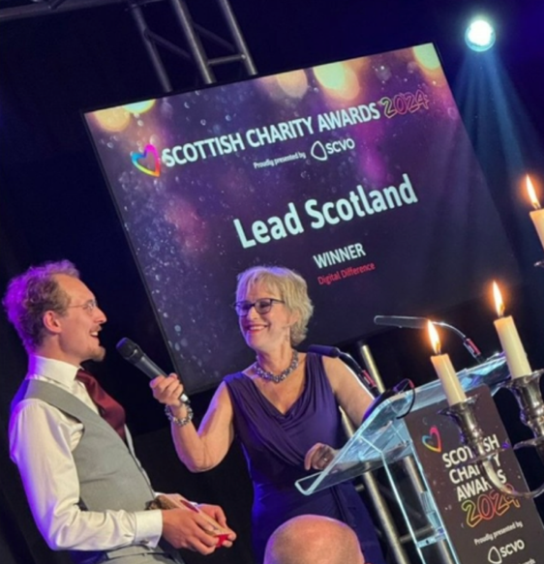Over the year, we have made fantastic progress, working with disabled sessional workers to help reduce the disability employment gap, as well as to help us reach into specific disabled communities. We have created a new online health checker for anyone wishing to audit their own digital health, available at digital.lead.org.uk. We ran in person sessions for a Deaf People’s organisation, ran a workshop for YouthLink Scotland’s digital conference, wrote blogs for Fearless and YouthLink Scotland, and to cap off a fantastic year, our hard work was recognised when we won the Digital Difference award at the Scottish Charity Awards 2024.

**Key stats**

Over 24-25, we delivered accessible workshop training on cyber resilience to 402 people, with 96% of attendees feeling more confident after the session, and attendees sharing their new knowledge with a further 3162 people. We have had 96 new learners join our online learning platform and supported 11 learners through our formal cyber resilience qualification. Alongside this, we have commissioned 6 new British Sign Language (BSL) clips on a range of cyber resilience and online harm topics to help improve access to this knowledge in the Deaf community. Finally, we attended and participated in 19 strategic forums, helping to raise awareness of the work we’re doing and how organisations can help.

**Accessible resources**

Over the last five years, we have built a substantial library of accessible guides to staying safe online, including guides in formats like Easy Read and British Sign Language (BSL). Over the last year, our guides were downloaded over 2000 times and partner organisations such as the Mhor Collective use our resources as part of their own training.

**Case Study: Deaf People’s Community Organisation**

We were approached by Police Scotland to help improve access to cyber resilience resources in the Deaf community, as they had been receiving reports of criminals specifically targeting Deaf people. We worked with a key Deaf people’s charity delivering BSL support to Deaf people, to produce 6 BSL clips on the topics that matter to their service users. These BSL clips sit alongside our other 7 BSL clips to create a fantastic library of BSL resources for Deaf people looking to learn about staying safe online. This led to us running an in-person workshop with the organisation, getting their service users thinking about staying safe online, which has in turn led to two attendees signing up to complete our formal cyber resilience qualification, so that they can become pillars of knowledge in the Deaf community, and cascade this onto others.

**Accessible workshop sessions**

Over 24-25, we ran 26 workshops aimed at boosting knowledge, skills and confidence around being safe online. We were delighted to be asked to take part in Scottish Learning Disability Week, where we ran four sessions for people with learning disabilities, with the sessions led by one of our sessional workers with lived experience of having a learning disability. After these sessions, we received some feedback from the organisers:

“LEAD are a fantastic organisation to partner with, incredibly generous with their knowledge and time and happy to adapt their training style to meet the needs of people we work with who have additional support needs. The work LEAD do is vital for people with learning disabilities as the more services are becoming digital first, as they are a group whose right to digital inclusion is most at risk”.

Alongside the work we did for Scottish Learning Disability Week, we ran workshops for Cyber Scotland Week. We have also worked with local authorities to upskill staff.

**Case study: Complex Care Social Work**

We ran a series of 6 workshops for a local authority’s Adult Social Care team, which had reported that they were spending an ever-increasing amount of time trying to support their service users to stay safe online, while not necessarily having the skills to do this effectively. These workshops were split over two mornings. 100% of attendees learned something new and had plans to share it, with the sessions having a total indirect reach of at least 73 people. Feedback from an attendee stated that they planned to:

“Utilise the easy read materials and also be able to support individuals to understand their cyder safety (and perhaps change a few of my own passwords now!). It was quite daunting to sit for a full morning online regarding cyber safety. However, Michael was extremely engaging, interesting to listen to, and I thoroughly enjoyed the session.”

**Accessible online learning platform**

Our accessible learning platform MyLead (<https://my.lead.org.uk>) has been further developed with 6 new cyber courses, including courses created to complement campaigns being run by Cyber Scotland Partnership on safe online banking.

Alongside the new courses, there have been two exciting developments with our online learning platform.

The first development is there is now a new ‘tools’ page, giving easy access to a range of useful digital tools for staying safe online. This is a one-stop shop for tasks from checking how secure a password is and checking to see if a website is safe, all the way through to using an AI-powered scam detection engine and helping to stop sextortion.

The other development is our fantastic digital health checker (available on digital.lead)/ This has been created with help from the fantastic team at Scottish Tech Army in response to feedback we’ve received from learners about how the volume of content they need to know to stay safe online can feel overwhelming – digital.lead offers a place to assess what you’re already doing, and where you have room for growth. It links back to MyLead, so if you identify areas you wish to improve, you can easily upskill to stay safe.

**Case study – MyLead learning**

Jenny (name changed) has completed every course on MyLead. Jenny loves learning, but when she started using MyLead. she was unsure about whether this style of self-directed learning would be right for her. After going through a course with Lead’s Learning and Development Officer, Jenny found that not only could she do it, but that she really enjoyed learning online. This is a quote from Jenny about one of our courses on MyLead.

“I like the layout of the course, and it has just the right amount of content. I like the fact the big words are highlighted. Its a good introduction before doing further cyber security. It's a good pathway to learning progression. I enjoyed my learning today because I feel I know more about the topic.”

**Formal cyber resilience qualification**

In 24-25, we supported 11 learners to achieve two qualifications, Cyber Security Fundamentals and Internet Safety at SCQF level 4 by delivering combined learning and teaching resources - tailored Education Scotland resources. 100% of learners achieved this award. We have had learners from all backgrounds undertake the course, from professionals working in this area to people who have come to it with very little confidence. Each learner has developed their confidence, skills and knowledge to have a thorough and well-rounded understanding of contemporary cyber resilience.

**Case Study 1: Beth**

Beth (name changed) works in a role where cyber security is key. However, she felt that she wasn’t especially interested in cyber resilience, but a recent phishing incident had left her feeling like she needed to upskill. Beth’s confidence grew throughout the course, and she felt that not only did she have a few more skills, but that it would be useful professionally too. Beth said:

“It was super beneficial for me to be able to see this process as my secondary and third level education was not within this country. This has also added to my CPD record for my professional role and this has helped me during my yearly review. I wish more people knew about the LEAD Scotland, their website and how amazing the courses are that they offer for free!”

**Case study 2: Rosemary**

Rosemary (name changed) had been trying to use digital devices for a little while and was able to manage a few basic tasks like sending an email and watching YouTube. However, she had no confidence in her abilities to do anything else with a device and doubted her abilities to succeed with formal learning, having not done any for over half a century. Rosemary was not sure she would manage online learning, as she thought it was going to be too complicated and thought that remembering all the steps to get into a Teams meeting would be beyond her. Rosemary was given a little in-person support from a sessional worker to help her get set up for the first few weeks. This allowed her to focus on the learning without worrying about the tech. After five weeks, Rosemary was confident enough to lead on setting up her device, and she managed it completely independently after another couple of weeks. This, and the learning she was doing, was transformative to her confidence. She said:

“I never thought in a million years I would get this. It’s all so different to when I was growing up, and I thought at my age it would be too late to learn it. Now though I think I can use my laptop to do a video call with my son and granddaughter in Australia. I am so proud of myself for being brave enough to have a go with this, thank you Michael.”

## Helpline and Information Services, Rebecca Curran-Scarlett

We run a specialist freephone helpline and information service, ensuring disabled people and their families understand their rights, funding, and support entitlements in post-school education. We are the only organisation in Scotland providing advice for disabled students to understand the complex benefit system and how it interacts with student funding. Our impartial service enables students to feel confident in making a timely and effective complaint or discrimination claim without fear of repercussions from their institution.

We answered 233 calls and emails on the helpline this year, taken from 95 callers from across 17 different local authority areas in Scotland. In addition, between April and October 2024 our helpline guides and factsheets were downloaded from our website 515 times by 419 unique users (we do not have data from October 2024-April 2025 because of migration to a new website).

The highest proportion of calls came from people living in Glasgow, followed by Edinburgh and then Fife. A third of callers did not disclose where they were calling from.

We received the highest volume of calls from people with more than one impairment, followed by autistic people and then people with a mental health condition. Callers with more than one impairment most commonly reported an autism spectrum disorder or mental health condition as their primary impairment.

More than a third of callers were learning in higher education, while just under a quarter were in further education. We also took a small number of calls related to employability training, community-based adult learning and school.

Over a third of calls related to a young person aged 16-24, and just under a quarter related to adults aged 25-44. We also took a few calls related to people aged over 44 and under 16.

One third of calls related to a student in dispute with their college or university or requiring advice about rights under the Equality Act. The other most common reasons for calling (in order) were how benefits would be affected by learning, student funding, transitions and choosing a suitable learning opportunity.

**Case Study**

We were absolutely thrilled to hear from a parent on the helpline this year who was a long-time repeat caller. After initially contacting the helpline seven years ago when her son Alex* was just 14 and had failed all of his National 5’s, Anne* got in touch to let us know he had just graduated from the University of Edinburgh with a degree in Mathematics! Anne wanted to thank us for the information, advice and support over the years to help get Alex back on the right track and progress to higher education via flexible and accessible learning pathways. Anne said,

“When I first contacted you for help it was very apparent that you were **reliable and consistent** in the support you offered us, and looking back at our emails from this time, they are testament to the work you put in **hunting out information** to help us **solve problems.**

In a nutshell, my son went from flunking every subject in National 5 to managing to get into a high-ranking University Degree (with all A’s) and then completing the Degree. This just goes to show what can happen when disabled kids get the support they need and also, don’t give up on their goals.”

You can [read Alex’s full story on our website here](https://www.lead.org.uk/2024/10/31/alexs-story/). *not their real names.

## Policy Work, Rebecca Curran-Scarlett

**Closing the gap - Advocacy and representation:** In March 2019 we wrote a briefing about the issues disabled students experience in accessing advocacy and representation when they are in dispute with their college or university. Increasingly callers ask us if we will provide advocacy and representation during meetings, with around one third of our calls related to this issue. We know there is limited availability for independent advocacy, eligibility criteria for services is restrictive, and waiting lists are long. In England and Wales, the dedicated Office of the Independent Adjudicator (OIA), was set up to review complaints by students about their higher education providers. They produce guidance, toolkits, resources and statistics all related to disabled student complaints. There is no equivalent in Scotland.

This year we re-visited our [Advocacy briefing from 2019](https://www.lead.org.uk/wp-content/uploads/2024/12/Advocacy-Paper-March-2019.docx) to dig deeper into the persistent barriers disabled students face in accessing support for dispute resolution and civil justice. The policy section of our website contains a blog called ‘[What about us?’](https://www.lead.org.uk/2024/12/20/what-about-us-advocacy-and-representation-for-disabled-students/) and has more detailed information about our findings. We used this evidence to apply for funding to expand the remit our helpline service to provide advocacy and representation, but we were unsuccessful. However, we are determined to continue to seek out new funding, using the evidence we have gathered in this last year.

**Influencing policy** is an important way by which we can achieve our long-term vision. Our work aligns with many key government policy areas and Scotland Performs’ outcomes and indicators, and our core funding comes from the Scottish Government. We influence policy from our position as an independent organisation. Involving disabled people in this work is intrinsic to our mission, ensuring their lived experience shapes practical solutions. One such disabled person who has worked with us many times over the years to influence change told us this year,

“Collaborating with the policy team has been fantastic, together we’ve campaigned to make access to higher education more equitable for disabled students. It’s given me the opportunity to speak in parliament about my experiences, meet with MSPs and attend meetings with advisory groups. Working with the team has really helped put the lived experience of disabled students front and centre.”

Some of the highlights from our policy work this last year include:

* **Responding to the call for evidence from the Scottish Parliament's Education, Children and Young People Committee's** [**inquiry into Widening access to higher education**](https://www.parliament.scot/chamber-and-committees/committees/current-and-previous-committees/session-6-education-children-and-young-people-committee/business-items/widening-access-to-higher-education)**.** Our Senior Policy and Information Officer was also invited to provide oral evidence at a committee hearing further to our submission. They specifically wanted to hear about what barriers still existed for disabled students accessing higher education and what could help to address those barriers. This was a particularly pertinent consultation for us to respond to as we have done extensive work on raising awareness and influencing change in this area in the past. We developed a survey and worked with various partners to disseminate it to disabled people to ensure their lived experience was included in our policy response. We received responses from 21 people which we collated for the committee. Common issues emerging from the responses included a lack of accessible pathways into higher education for disabled people on a non-linear learning journey and a rolling back of remote learning provisions introduced during the pandemic.

* **Fair Access to University -** After six years of campaigning, influencing work and collaboration, which began with our [fair access campaign](https://www.change.org/p/make-access-to-university-fairer-for-disabled-people), Universities Scotland published a new sector statement and set of shared principles that guarantee fairness for disabled applicants as well as welcoming and encouraging them to apply. A brand new disabled student guide was also published as part of the work. We were invited to write a blog, [‘Are we Fair yet?’](https://www.universities-scotland.ac.uk/are-we-fair-yet/) for their website to highlight the importance of fair access for disabled people by reflecting the lived experience evidence we receive on the helpline.

* During our **parliamentary reception** this year we invited four participants from our Right to Learn project to speak. These four disabled people co-produced our [Guide to Community Based Adult Learning](https://www.lead.org.uk/a-guide-to-community-based-adult-learning/) using their own lived experience as disabled learners. Their input at the event really helped to shine a light on the transformative power and flexible nature of community based adult learning. Partners and policy makers at the event were particularly receptive to hearing our four participants talk, with one partner saying,

"One of the standout moments for me was learning about Lead Scotland's CBAL guide. It highlights how learning in the community gives everyone a voice, build confidence and creates opportunities -... Amazing work from a talented group of people"

## Looking ahead to 2025-26

As we look ahead to the coming year, we have plenty of new work to do!

* **Develop our New 3-Year Strategic Plan** – we look forward to working with our stakeholders to develop our new strategic plan for 2026-29!

* **Diversify our funding sources:** We will seek dedicated funding to identify the added value of services/courses we already have and consider what new courses and services will add value.
* **Seek more Digital Health and Wellbeing Projects:** build upon our successful Aberdeenshire pilot and seek funding to be able to deliver learning projects which enable people to use key digital health services and improve wellbeing.
* **Customer/stakeholder research:** we are planning to undertake more research to hear what our stakeholders need and want from us to add to the evidence base in Scotland and inform/design grant applications and our next strategic plan.
* **Build new partnerships:** Increase our strategic engagement work and forums in line with our expanded Cyber Project target and our strategic ambition to support more people to manage their cyber risks.
* **Change of Chief Executive Officer:** after 10 years as CEO and a 25-year relationship with Lead Scotland in eight different job roles, Emma Whitelock will move on in July 2025 and we will miss her, her hard work and dedication has driven Lead Scotland forward. She leaves the organisation in a good place ready for her successor to take up the reins to lead the team to continued success.
* **Reduce educational and social exclusion:** undertake research and seek funding opportunities which will enable us to deliver learning projects with adult befriending opportunities to offer new pathways into learning.

## Our supporters

We gratefully received income in 2024-25 from:

* Aberdeenshire Council
* Arnold Clark
* Capital Credit Union
* Co-operative Local Community fund
* Dundee Council
* East Lothian Council
* Fife Communities Trust
* Fife Health and Social Care Partnership
* Friends of Lead North Lanarkshire
* Hugh and Mary Miller Bequest
* Highland Council
* Highlife Highland
* Keegan & Pennykid
* Perth and Kinross Council
* Moray Council
* Network ROI
* North Lanarkshire Council
* Scottish Government
* Sir Jules Thorton Trust
* Individual donations

Thank you so much, your support is critical to our mission!

Lead Scotland, Studio 1.09, St Margaret's House, 151 London Road, Edinburgh, EH7 6AE. Scottish Charity SC003949, Scottish Company Ltd by Guarantee 110186.

Should you require this report in another format please email us at enquiries@lead.org.uk or call 0131 228 9441.

End of Document.