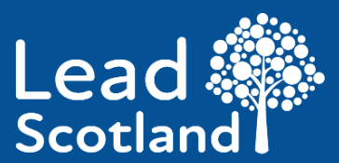

Our Annual Impact Review for 2024 to 2025


Easy Read


About this document

 | This is an Easy Read document.
 | It is a review.
 | A review looks back at work that has happened.
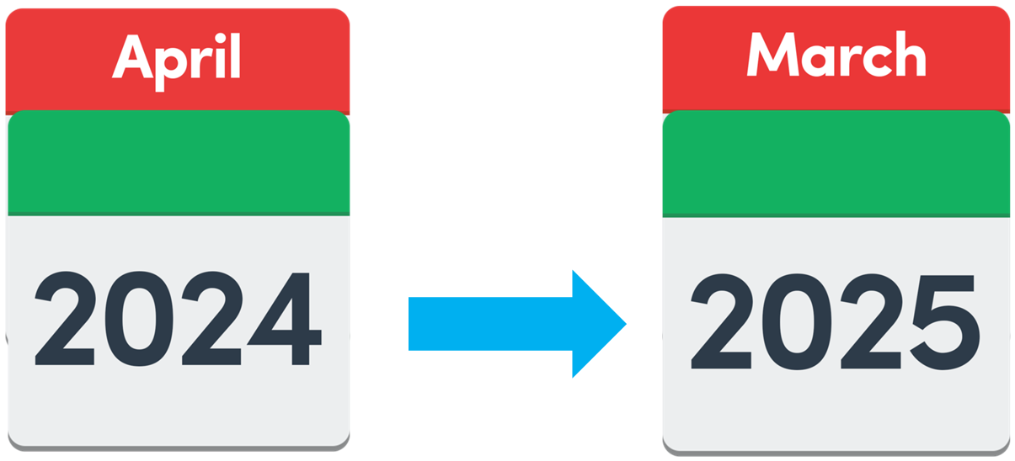 | This review tells us about Lead Scotland’s work from April 2024 to March 2025.

About Lead Scotland
 | Lead Scotland is a charity which helps disabled people and carers in Scotland to:  - learn new skills  - make friends  - get advice and information

Introduction
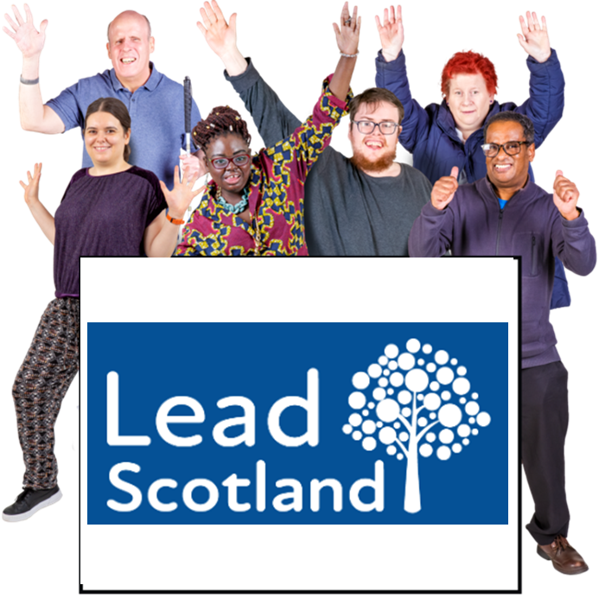 | We are proud to celebrate 45 years of Lead Scotland.
 | But there are challenges now, like less funding and more poverty.
 | Poverty means not having enough money to pay for basic needs like food, clothes or heating.
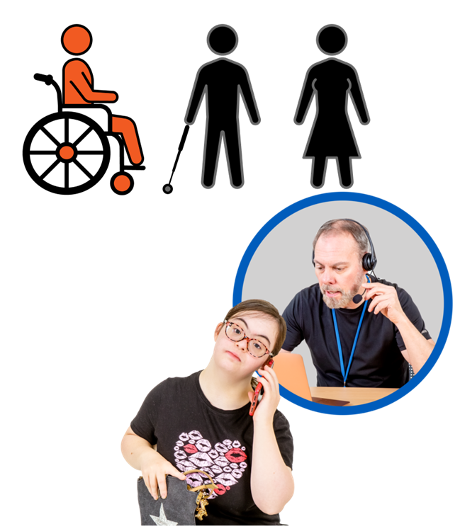 | 1 in every 3 people who called our National Disabled Students Helpline this year were having difficulties with their school or college.
 | We have spoken up for them to make their learning better.
 | We thank everyone who supports us and gives us money.

Work Lead Scotland has done in 2024 to 2025

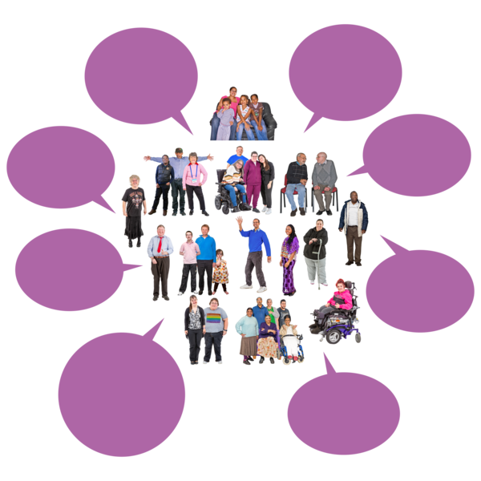 | We have reached more people.  Our services have helped nearly 1 thousand 6 hundred people.
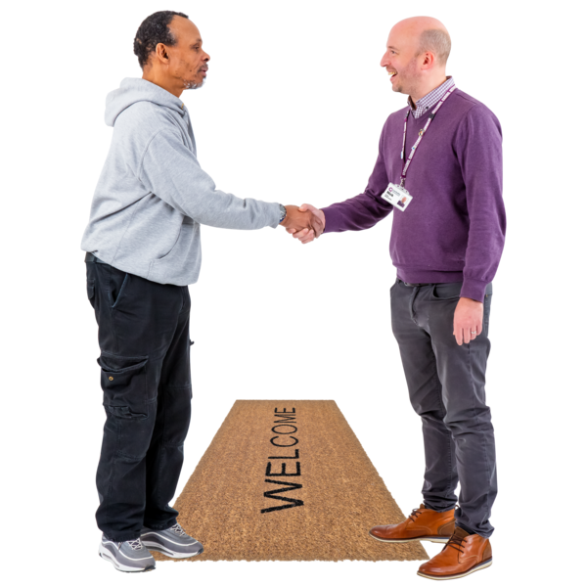 | Half our learners got a home visit from a Lead Scotland worker.  Home visits are very important.
 | Lead Scotland ran 74 learning events in different areas across Scotland.  These learning events were a chance for people to try a bit of course and see if they liked it.
 | We have worked hard for 6 years to change how disabled people are supported to join a university.  Now it is fairer for disabled people.
   | Last year we made nearly 70 new qualifications.  Qualifications are certificates someone can earn by learning skills or knowledge at a certain level.
 | But this year we have made more than 1 hundred and 50 new qualifications.
 | 94 new people signed up to learn.  Learners finished 1 hundred and 55 courses.
 | 4 hundred and 24 people started our new digital checklist in the first 3 months.  You can see the checklist tool by clicking on this blue link to reach our Digital Lead webpage.

Our aims and how we did
 | There were 4 aims we wanted to work hard to make happen.
 | Here are the 4 aims and the work we did on them.  These 4 aims are also called our strategic objectives.

Aim 1
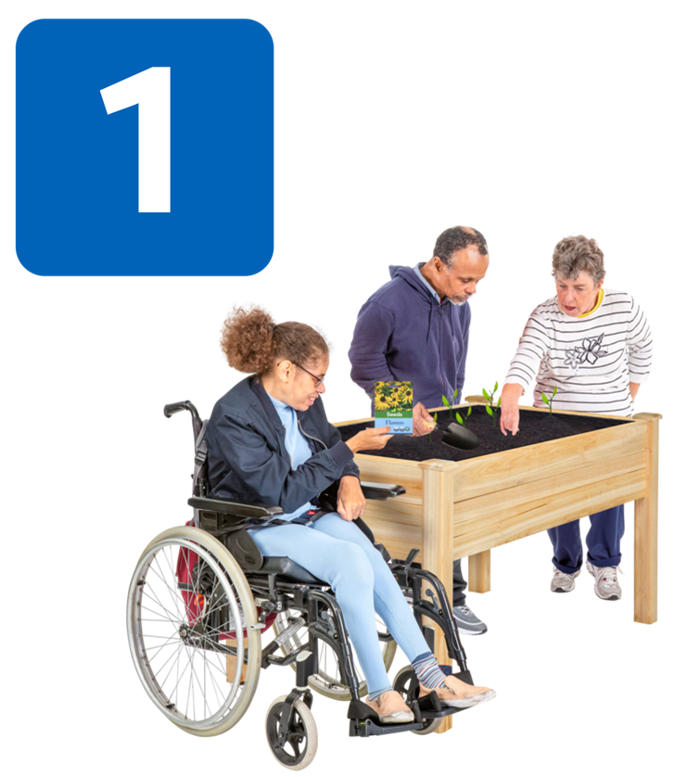 | Aim 1 was to get more disabled people and carers across Scotland learning new skills.
 | This year we supported 7 hundred and 30 local learners.  This is almost 1 hundred and 50 more learners than we supported last year.

Aim 2
 | Aim 2 was to get more disabled people and carers learning from home to give them more confidence and more skills.  This also includes staff and volunteers.
 | Volunteers are people who give their time to work for free.
 | We helped 4 hundred learners from 27 local council areas across Scotland.
 | They joined our Cyber Scotland project.  Almost everyone we asked said the project had made them feel more confident about staying safe online.

Aim 3
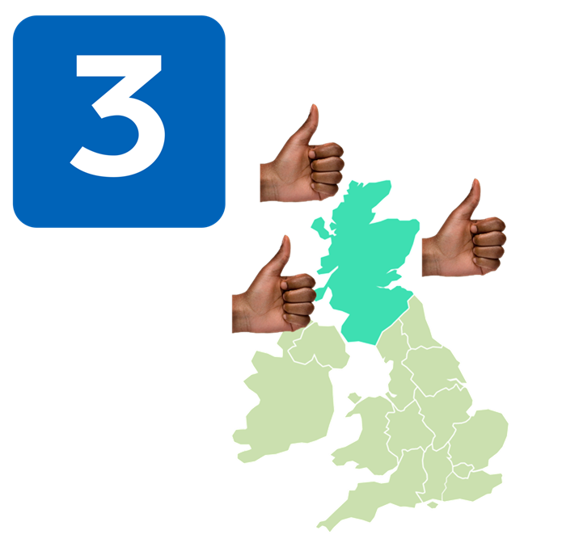 | Aim 3 was to start new befriending services reaching more of Scotland.
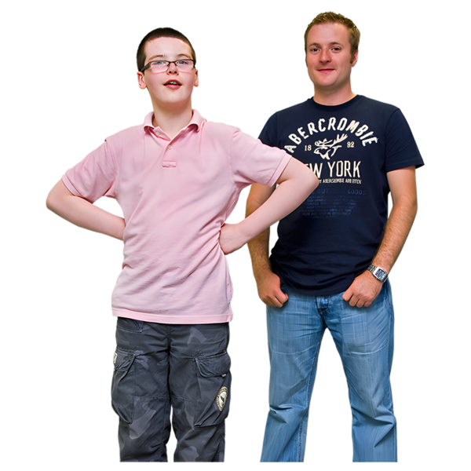 | At Lead Scotland, befriending means:  - supporting someone to build their confidence  - supporting someone to learn new skills
 | Less people are volunteering as befrienders at the moment.
 | We are looking at new ways to train volunteers online.

Aim 4
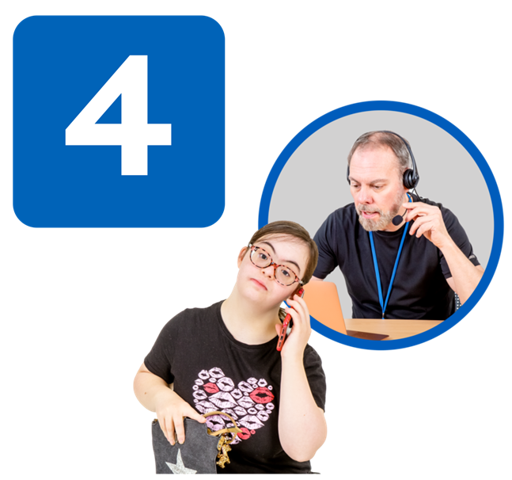 | Aim 4 was to reach more people with our helpline and our information services.
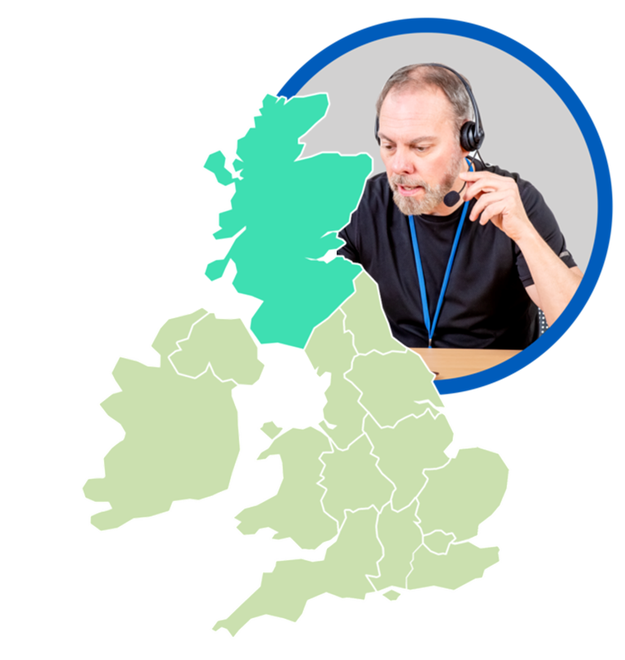 | We run the only helpline for disabled students in Scotland.
 | There needs to be more support for disabled students to have their say, when there are problems with their college or university.
 | We are looking for more funding so that our staff can speak up for disabled students to help solve problems.

Next year
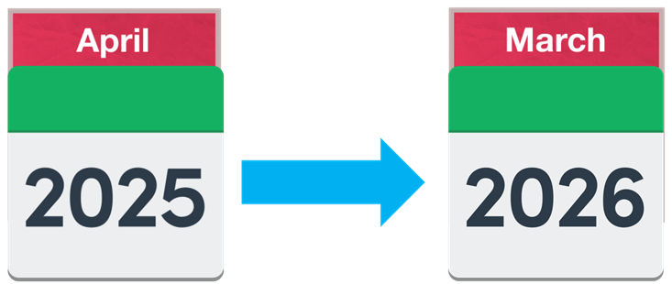 | Between April 2025 and March 2026 we want to:
 | - begin our new 3 year plan from 2026 to 2029
 | - look for more funding
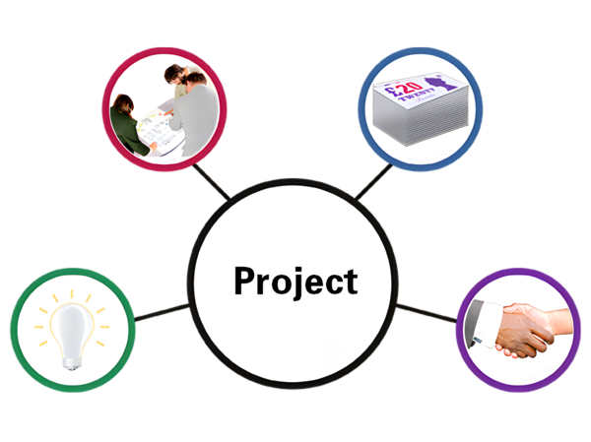 | - do more Digital Health and Wellbeing Projects
 | - find out what everyone needs Lead Scotland to do more of
 | - work together with more organisations
 | - thank Emma Whitelock who is leaving Lead Scotland after being our Chief Executive Officer for 10 years
 | - help more people to learn so that fewer people feel left out


