Lead Scotland

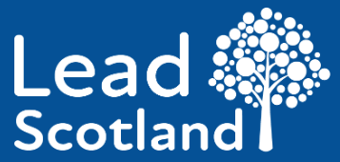

How to spot a scam message
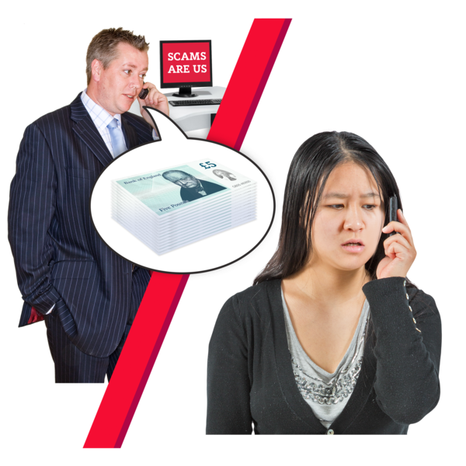

Easy Read

Copyright images © Photosymbols. Prepared by Disability Equality Scotland

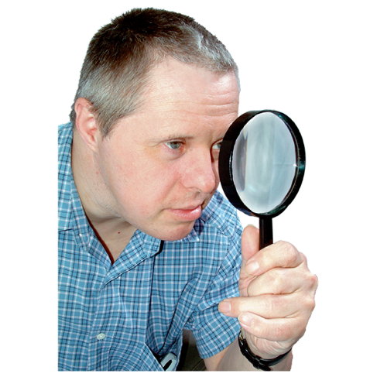 | This document tells you how to spot:  - scam emails  - scam text messages  - scam phone calls
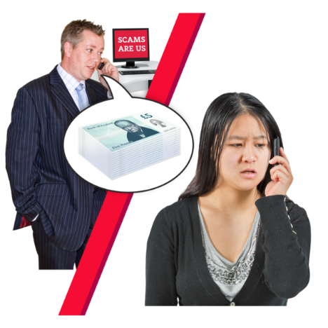 | Scam means a crime where someone is tricked into giving away their:  - personal information  - money
 | Scams are done by criminals so that they can get money.
 | About scams
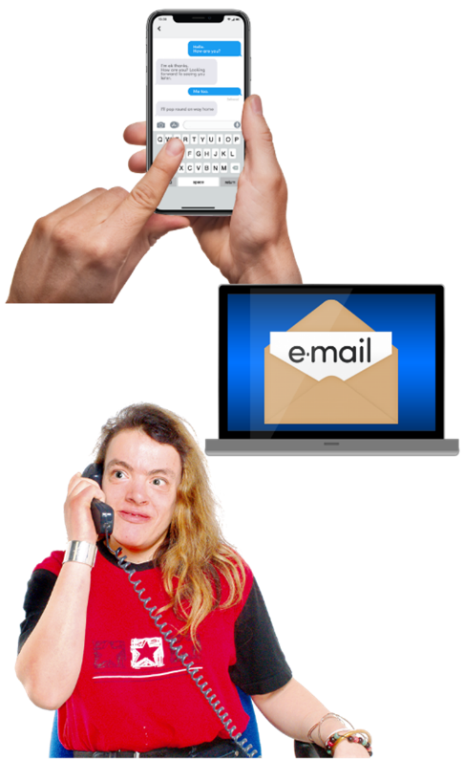 | Criminals might send you:  - a text  - an email  - a phone call  - a message on social media
 | They often pretend to be a person or an organisation that you trust.
These scam messages used to be easier to spot.
They often had lots of spelling mistakes and bad pictures.
 | But many scams are more clever now. They are hard to spot.
 | How to spot a scam
 | Scams often have these 5 things:
 | 1. It says it’s from someone important
 | Scam messages often say they are from someone important.
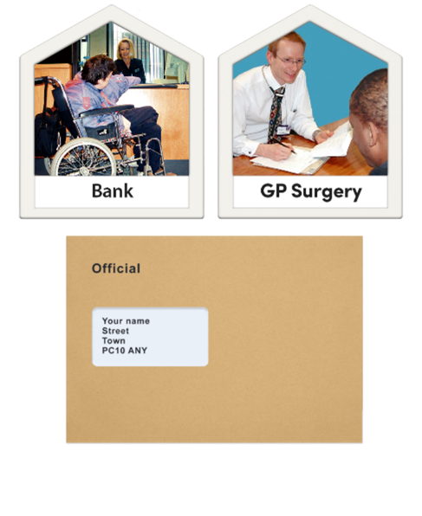 | It might be pretending to be from:  - your bank  - a doctor  - a solicitor or lawyer  - a government department
 | 2. It says it is urgent
 | Urgent means it needs doing fast.
 | Scam messages often say you have only got a short time to reply.
It might say things like:
- ‘within 24 hours’
- ‘immediately’

 | Criminals often say there will be a fine to pay if you don’t do something. Or something else bad will happen.
 | 3. It makes you feel a strong emotion
Scams often use words which:
- threaten you
- tease you

Scam messages often make you feel emotions like:
- panic
- fear
- hope
- curiosity

 | 4. It offers something special
Scam messages often offer you something:
- special – like concert tickets
- needed – like money
- hoped for – like a medical cure
- exciting – like a good deal

 | Criminals hope that this will make people reply to the scam message quickly.
 | 5. It is linked to what is going on in the news or in real life
Scams are often linked to real life.
They might be linked to:
- something that has just happened in the news
- something happening in real life
- the time of the year – like the end of the tax year

 | How to check if a message is real
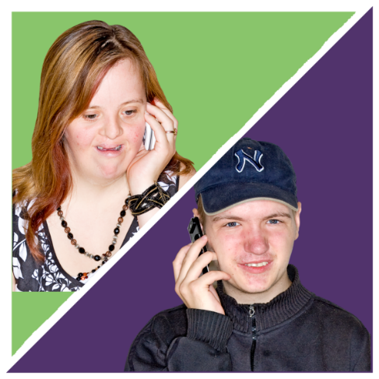 | To check that a message is real and not a scam you must ask the organisation or person.
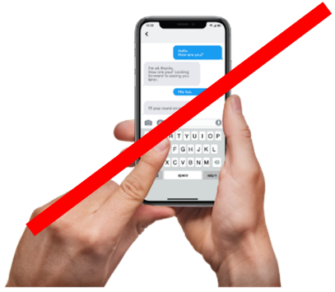 | Don’t use the contact details from the scam message.
 | Find the real email address or phone number from their official website – and use it to ask the organisation if the message was from them or not.
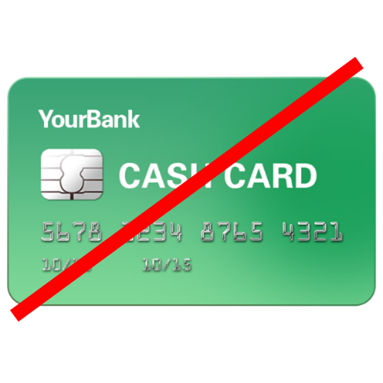 | Remember that important organisations – like your bank – will never ask you to put your personal information in an email.
 | How to be safer
Criminals look at places like:
- your Facebook pages
- your Twitter pages
- your Instagram pages
- other online information about you that can be found in a search
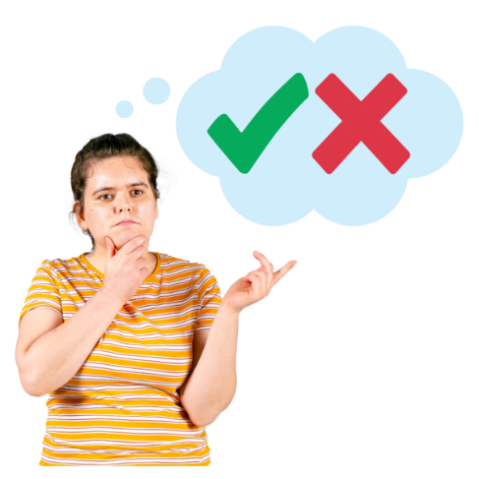 | Decide what you want to put on these pages and what you want to stay private.
Use the privacy settings to decide:
- who can see your information
- who can’t your information

