Lead Scotland
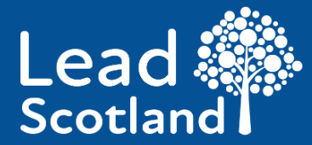

How to carry on learning after you have left school in Scotland

Easy Read

Copyright images © Photosymbols. Prepared by Disability Equality Scotland

This is a guide.
It is about how you can carry on learning after you have left school.

 | Who this guide is for
This guide is for:
- young people in Scotland
- adult learners in Scotland
- disabled people in Scotland
- disabled people’s carers in Scotland

 | How you can carry on learning
You can choose to learn:
- at home
- at college
- at a local centre
- anywhere else that feels right

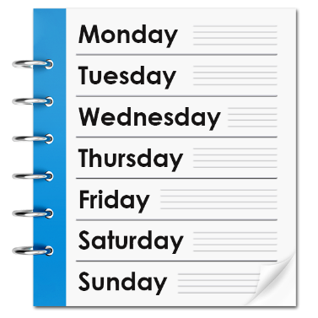 | You can choose to learn for a few hours a week.  Or you can learn full time.
 | 3 ways to carry on learning
1 | 1. Adult Learning in your community
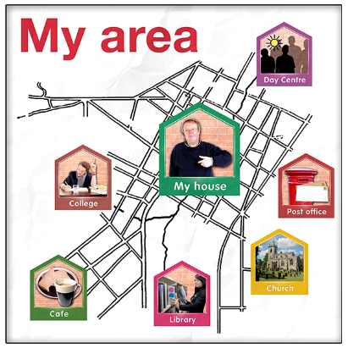 | Adult Learning in your community is also called community based adult learning or CBAL.
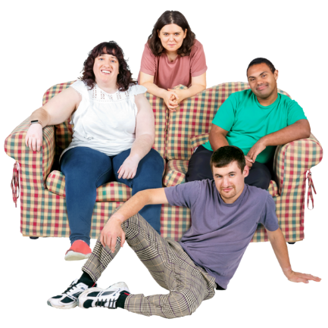 | This kind of learning can happen:  - in community centres  - in learning centres  - in libraries
Adult learning in the community is often organised by:
- the local council
- charities
- other organisations
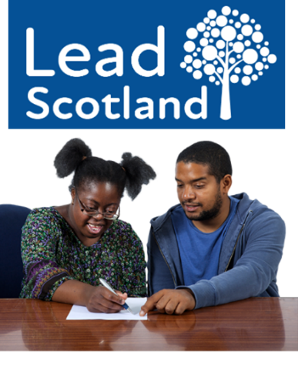 | For example, at Lead Scotland we can give free support to disabled people and carers.  This can be things like:  - 1 to 1 sessions in your home  - group sessions in your community  - getting a Learning Co-ordinator to help write an action plan to suit you
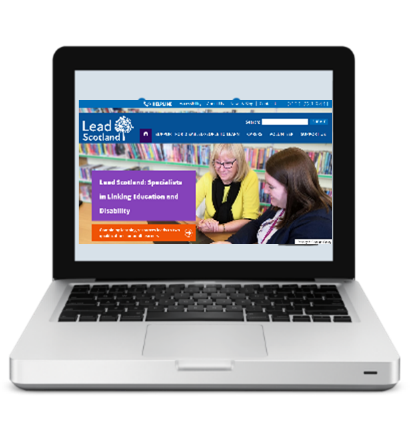 | If you want to know more about Lead Scotland’s support, you can click here on Lead Scotland's website.
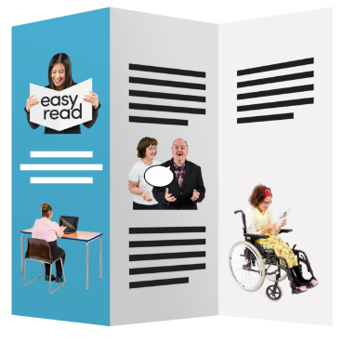 | If you want to know more about adult learning in the community, you can click here on Lead Scotland's website.
2 | 2. Further Education
 | Further Education means learning for people who are 16 years old and older.
 | Further Education courses are often about real life and work.
There are courses about:
- computer skills
- speaking and listening skills
- life skills – like money or cooking
- learning English for people who speak a different language
- work skills – like plumbing or childcare

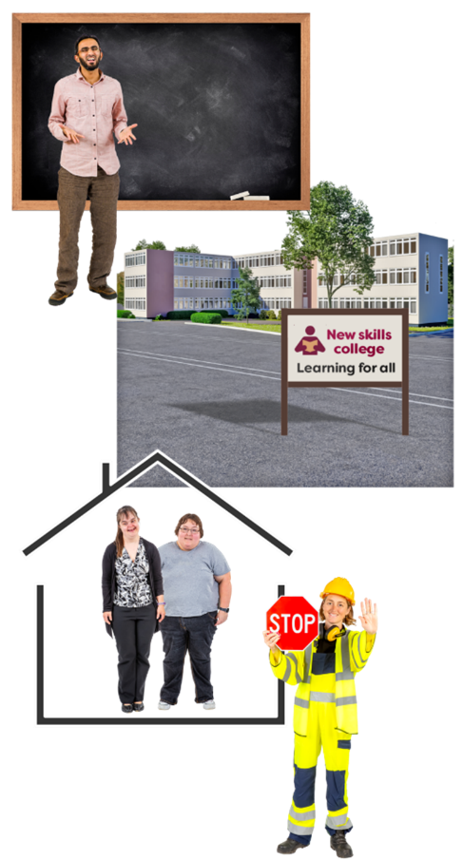 | Further Education courses can happen in places like:  - schools  - colleges  - a mix of school and college  - specialist colleges for people who have learning difficulties or disabilities  - home  - work
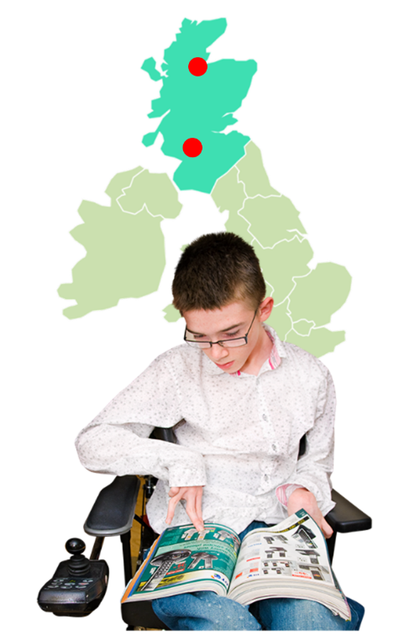 | Scotland has 2 specialist colleges. 1 near Inverness and 1 near Glasgow.  To find out more about Cantraybridge College near Inverness, click here on Cantraybridge College's website.  To find out more about Corseford College near Glasgow, click here on Capability Scotland's website.
 | How to start a Further Education course
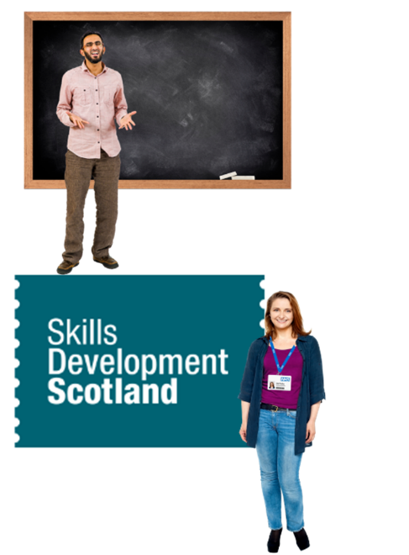 | There are lots of people who can help you to choose a course.  You can talk with:  - the person leading the course – they are called a tutor  - a careers advisor at Skills Development Scotland organisation – click here on Skills Development Scotland's website  A careers advisor is someone who knows about different jobs and choices.
These people will also help you to find the right forms or the right website button to ask to join the course.
This is called applying for a course.
It is a good idea to apply as early as you can before a course starts.

You can also talk with a disability advisor.
A disability advisor is someone who knows about disabilities and choices.
They can help you get the right support on your course.

3 | 3. Vocational Training
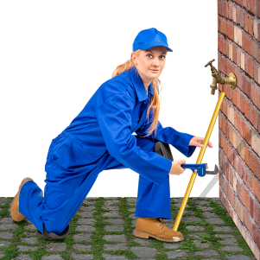 | Vocational training means courses which teach someone skills for a job.
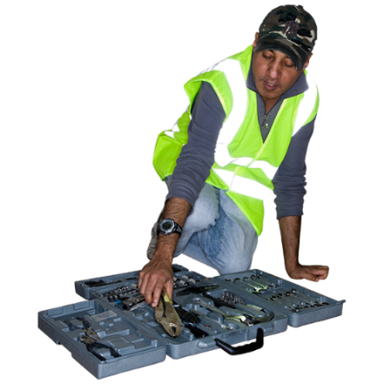 | These courses often happen at the work place.  They can be for new learners or for people already working who want to learn more.
Sometimes you get paid while you are working and learning.
Sometimes your learning gets you a qualification.

 | Different kinds of Qualifications
A qualification is when you pass an exam or a course.
It means you have learned a set of skills and passed a test.

There are lots of different qualifications.
Some are easier and shorter to do. Some are harder and longer to do.

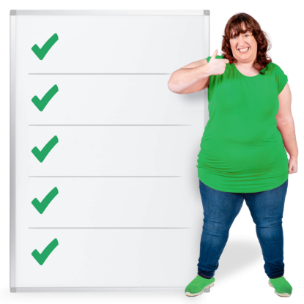 | 1. These are some of the qualifications for people who need extra support:  - International Certificate in Digital Literacy – how to use a computer  - English for Speakers of Other Languages  - Steps to Work award –  - Award in Volunteering Skills
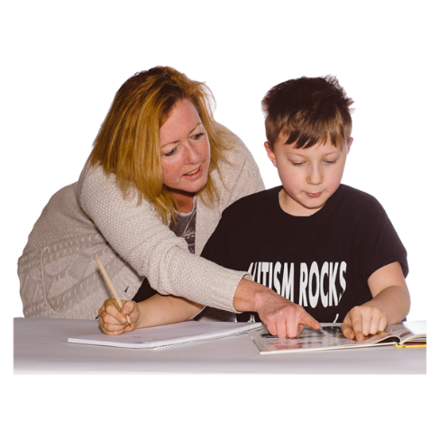 | Volunteering means working or helping an organisation but not being paid.
 | 2. Scotland has an important organisation called the Scottish Qualifications Authority.
 | The Scottish Qualifications Authority is often called SQA for short.
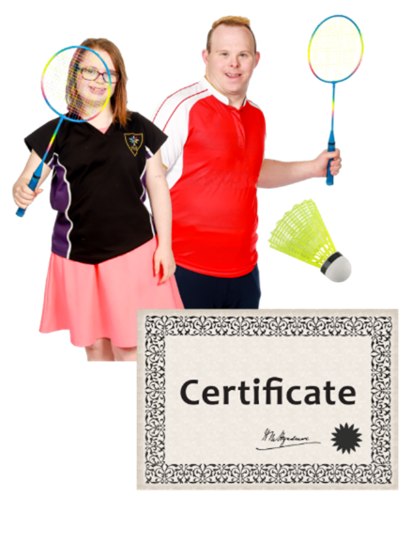 | SQA have National Qualifications in many different things – like sports, photography and science.
The National Qualifications are called:
- Nationals
- Highers
- Advanced Highers

 | They start at National 1 – which is for people who need a lot of support to learn.
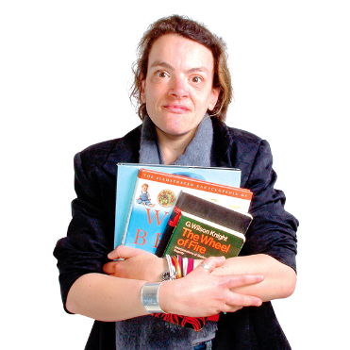 | They go up to Advanced Highers – which is for people who might be carrying on with education at university or at work.
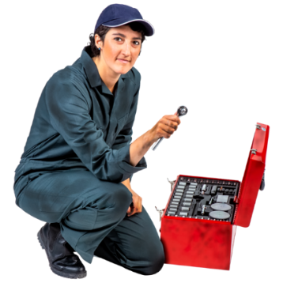 | 3. Scottish Vocational Qualifications are about work skills and work knowledge.  They are often called SVQs for short.
1 5 | They start at SVQ Level 1 – which is for beginner workers.  They go up to SVQ Level 5 which is for experienced managers.
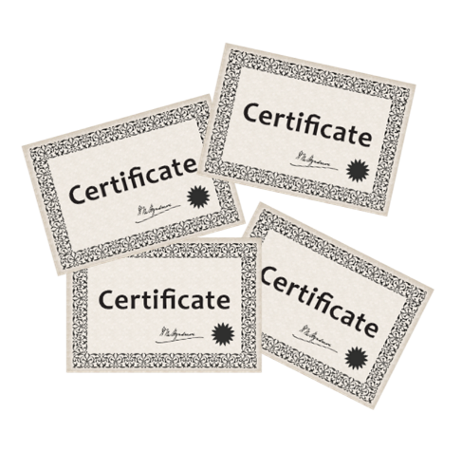 | 4. Other qualifications  There are lots of other types of qualifications too.  Things like:  - SQA Core Skills  - National Certificates  - National Progression Awards  - City and Guilds
 | Learning you have already done
Don’t worry if you do not have many or any qualifications.
Lots of places will look at other learning you might have already done.

These might be things like:
- life experience – what has happened in your life so far
- work experience – what work you have done
- voluntary work – work you have done with no pay
 | Support for disabled students
When you fill in an application form for a course it might ask you if you have:
- a disability
- support needs

 | You don’t have to answer that question.
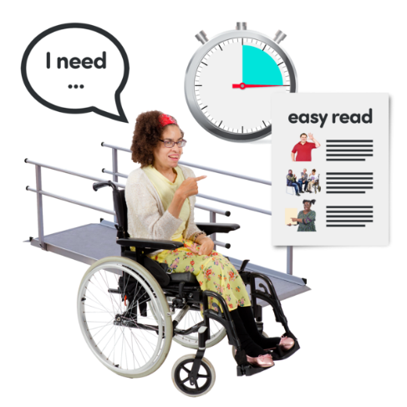 | But if you do, the organisation has to try and give you the support you need.
 | You can find out more if you click here on Lead Scotland's website.
 | Different kinds of support for disabled students
 | You might get support with your learning – things like computer software or extra time in exams.
 | You might get support with your life – things like help getting to college or help making meals.
 | You might get support with your health – things like medicines and exercise.
You might get support with your career.
A career is the different courses and work you do during your working life.

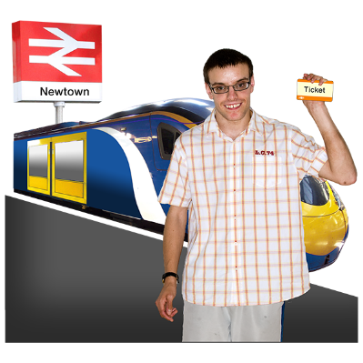 | You might get support with travelling to learn – things like taxis, train fares and money.
To find out more about who has the money to help you, please click here.
The link takes you to our main guide. Go to the part called ‘Funding for disabled learners’.

 | Carers
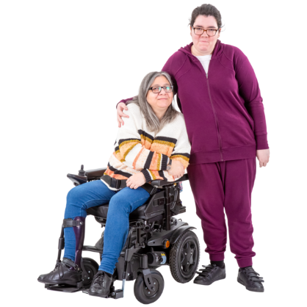 | An unpaid carer is someone who:  - helps someone else to do things like eat, wash, dress, get out  - does not get paid to do it
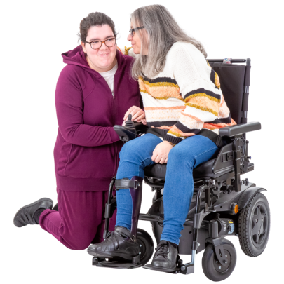 | It can be harder for carers to carry on learning after they have left school.
There is lots of support offered to carers.
Things like allowances. This means money paid to carers every month.

To find out more about what kind of help there is, please click here.
The link takes you to our main guide. Go to the part called ‘Support services for carers’.

 | Money
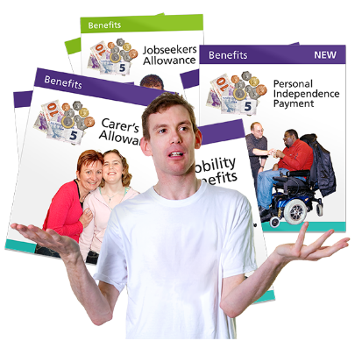 | Disabled people can get extra money to help them.  These are often called benefits.
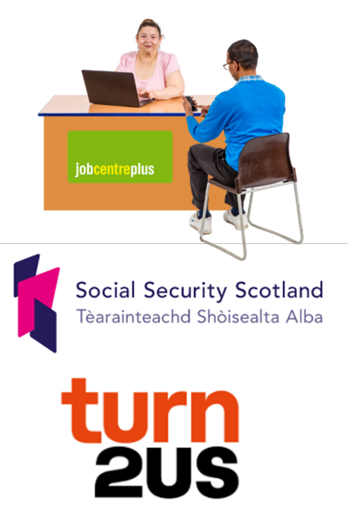 | There are lots of organisations who will help you work out your benefits.  Some of them are:  - Jobcentre Plus  - Social Security Scotland  - Turn2Us
You can also phone us on our Lead Scotland free helpline at
0800 999 2568.

Copyright images © Photosymbols. Prepared by Disability Equality Scotland

