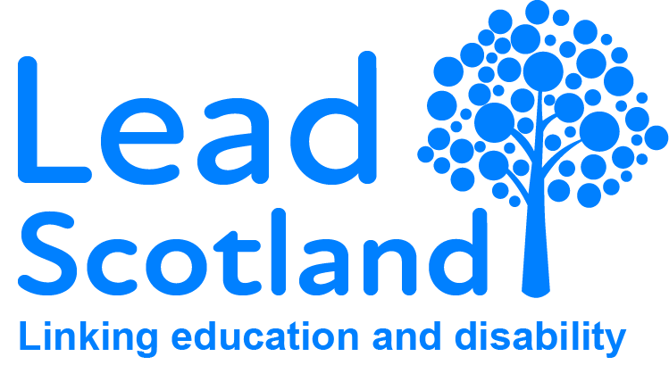

Disabled Students’ Allowance Factsheet – How to apply

About this factsheet
This factsheet was created by Lead Scotland in collaboration with disabled people. It explains what Disabled Students’ Allowance is, who provides it, what you can get and how to apply for it. Lead Scotland is a charity providing support for disabled people to learn. You can read more about what we do and access all of our free guides and factsheets on our website: www.lead.org.uk

About Disabled Students’ Allowance
If you are disabled, have a mental or physical health condition or additional learning support needs, your college or university have a duty to support you and remove or reduce the barriers you face in learning and studying.
Support could include getting extra time to complete your exams, offering you specialist equipment or providing you with an educational support worker.
If you are studying at Higher National Certificate (HNC) Level or above, you may also be able to claim extra funding to support you to learn.
This extra funding is called Disabled Students’ Allowance (DSA). DSA is available regardless of how much income or savings you have, it does not need to be paid back and it does not affect any benefits or other student funding you get.
It is provided by the Student Awards Agency Scotland (SAAS) if you are ordinarily resident in Scotland.

DSA is split into three parts:

The Basic Allowance
This is for items such as extra photocopying, braille or Livescribe paper and ink cartridges. The maximum amount each year is £1,725 (pro rata for part time study).

The Large Items Allowance
This is for items such as assistive technology, specialist software, laptops, scanners and printers. The maximum amount is £5,160 for the whole of your course of study (not per year).

The Non-medical Personal Help Allowance
This is for any course related personal assistance you need. For example, sign language interpreters or communication assistants, proofreaders or autism/mental health mentors. The maximum amount each year is £20,520 (pro rata for part time study).
Click here to read the SAAS guide to the non-medical personal help allowance.
You can also get help with travel costs if you cannot use public transport as a result of being disabled. For example, if you experience anxiety on buses then you may be able to get funding for a taxi. Or if you have mobility issues you may be able to get milage paid for you or someone driving you.

How to apply
If you are applying for DSA for the first time, follow the below steps. The whole process of applying for DSA and arranging support can take a few months to arrange, so it’s really important you don’t wait until your course starts before you apply. Check out our Tick the box blog, which talks about the importance of letting your college or university know you are disabled.
Applications for DSA open every year around the end of April. This is a quick guide to the process, please follow this link for the full SAAS guidance notes on applying for DSA. Although most colleges and universities will not start to process your DSA application until you have a confirmed offer, some will, so contact the institution you are expecting to attend to discuss it with them as early as possible.

Step 1: Speak to an adviser
Speak to a Disability Advisor at the college or university to discuss the impact your impairment or health condition might have on your learning and studying. Each college and university will have a Disability Services department, but they may have slightly different names, such as ‘Learning Support’, ‘Supported Learning’ or the ‘Inclusion Team’. Continue to Step 2.

Step 2: Your appointment
If the Disability Advisor thinks you are likely to be eligible for DSA, they will invite you to an appointment to discuss this further, unless you are a distance learning or Open University (OU) student, in which case skip to Step 6. You may have to wait until after you have a confirmed offer for this appointment. When you go to the appointment, make sure you take an accepted form of medical evidence (page 7), or ask a medical professional to complete this medical evidence form. Remember that even if you are not eligible for DSA, your college or university still have a duty to provide you with support. Continue to Step 3.

Step 3: Needs assessment
If your college or university is validated to carry out needs assessments, then this may happen during your first appointment, otherwise it will be scheduled for a later date – there may be a long waiting list. A needs assessment looks at what support, adjustments and equipment you might require while you are studying. See our factsheet on how to prepare for a needs assessment here. Most colleges and universities in Scotland are validated to carry out needs assessments, but if yours is not, SAAS will refer you to one of three access centres in Scotland. Skip to Step 5 if your college or university is not validated to carry out needs assessments, otherwise continue to Step 4. The following institutions are not validated to carry out a SAAS DSA needs assessment:
- Edinburgh Napier University
- The Open University
- The Royal Conservatoire of Scotland

Step 4: The DSA form
After the needs assessment, the assessor will support you to complete the DSA form as they need to sign it and fill part of it in themselves. They will also produce a needs assessment report, stating what support and equipment they recommend for you. The assessor will let you review this, to make sure you agree with what they are recommending. Once the form is completed and the needs assessment report and medical evidence is documents are all ready, you can upload them in your online SAAS Account using the document uploader. Now go to Step 8.

Step 5: If your College/University can’t carry out assessments
If your college or university is not validated to carry out needs assessments, the Disability Advisor will support you to complete the DSA form at your appointment, leaving the recommendations section blank, and instead ticking the box requesting a referral for a needs assessment at an Access Centre. There are three Access Centres in Scotland:
- The University of Dundee
- Edinburgh College
- New College Lanarkshire
You may also be able to request a home appointment if you cannot attend an access centre due to being disabled. You should then upload the DSA form and your medical evidence in your online SAAS account using the document uploader. Skip to Step 7.

Step 6: If you are a distance learning/Open University student
If you are a distance learning/OU student, the Disability Advisor will provide guidance on filling in the DSA form over the phone or in an online meeting. They will then ask you to send the form to them along with a copy of accepted form of medical evidence (page 7) or this completed medical evidence form.
When the disability advisor receives your DSA form, they will complete their part, sign it and send it back to you. You should then upload this in your online SAAS account using the document uploader. SAAS will then make a referral for you to have a needs assessment at an Access Centre. A needs assessment looks at what support, adjustments and equipment you might require while you are studying. There are three Access Centres in Scotland:
- The University of Dundee
- Edinburgh College
- New College Lanarkshire
If you are studying at the University of the Highlands & Islands (UHI), you may be able to have your assessment carried out via video conferencing, discuss this with your Disability Advisor. You may also be able to request a home appointment if you are unable to attend an Access Centre due to being disabled. Continue to Step 7.

Step 7: Report for SAAS
You should receive a letter/email/phone call from the Access Centre with an appointment to go in for your needs assessment. After your needs assessment, the Assessor will produce a report for SAAS, recommending what support and equipment you will need, and you will have a chance to review this before they send it off to SAAS. Continue to Step 8.

Step 8: Your Award Letter
If your application for DSA is successful, you will receive an award letter in the post from SAAS, confirming what funding for support and equipment they will provide. Read the DSA guidance notes or speak to your Disability Advisor to find out when and how you will get the money and what you need to know about purchasing equipment and arranging non-medical personal help.

Further Information
You can download the DSA application form here. Make sure you download the correct form as there are two versions, depending on your circumstances.
If you have any questions about applying for DSA, then you can contact the SAAS helpline on: 0300 555 0505 and then press option 1.
If you are unhappy with the needs assessment report you should discuss this with your assessor. If you cannot resolve the situation informally then you should make a formal appeal to ask them to review the decision. In rare circumstances you can ask SAAS for a new needs assessment from a different assessment centre independent to your case. If you want to appeal a decision made by SAAS related to your application then you can access their appeals process here.
You can also contact the Lead Scotland Disabled Students’ Helpline about DSA or with any other queries related to being disabled in post-school learning on Freephone: 0800 999 2568.
We are open from 10am-12pm on Tuesdays and Fridays and 2pm-4pm on Mondays, Wednesdays and Thursdays.
You can also email us: info@lead.org.uk
BSL users can get in touch with us or with SAAS by using Scotland’s British Sign Language Interpreting Video Relay Service (VRS), Contact Scotland, which is available to any BSL user with a smartphone or desktop PC with a webcam, and the Contact Scotland app.
We also have a full range of guides related to post-school learning and disability available on our website here.

